

NEHRU COLLEGE OF ENGINEERING AND RESEARCH CENTRE
(NAAC Accredited)
(Approved by AICTE, Affiliated to APJ Abdul Kalam Technological University, Kerala)

DEPARTMENT OF COMPUTER SCIENCE AND ENGINEERING
COURSE MATERIALS
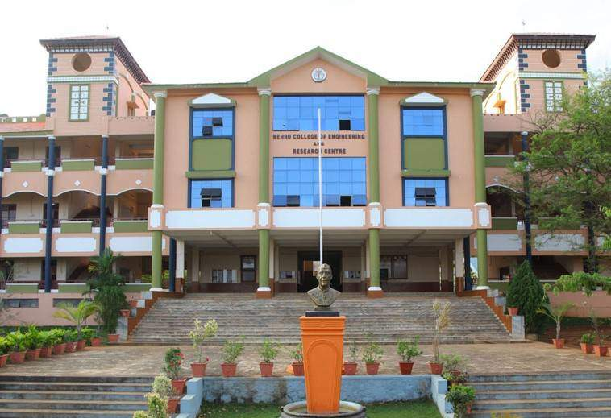
CST203 LOGIC CIRCUIT DESIGN
VISION OF THE INSTITUTION
To mould true citizens who are millennium leaders and catalysts of change through excellence in education.
MISSION OF THE INSTITUTION
NCERC is committed to transform itself into a center of excellence in Learning and Research in Engineering and Frontier Technology and to impart quality education to mould technically competent citizens with moral integrity, social commitment and ethical values.

We intend to facilitate our students to assimilate the latest technological know-how and to imbibe discipline, culture and spiritually, and to mould them in to technological giants, dedicated research scientists and intellectual leaders of the country who can spread the beams of light and happiness among the poor and the underprivileged.

ABOUT DEPARTMENT
- Established in: 2002
- Course offered : B.Tech in Computer Science and Engineering
M.Tech in Computer Science and Engineering
M.Tech in Cyber Security
- Approved by AICTE New Delhi and Accredited by NAAC
- Affiliated to. A P J Abdul Kalam Technological University.

DEPARTMENT VISION
Producing Highly Competent, Innovative and Ethical Computer Science and Engineering Professionals to facilitate continuous technological advancement.

DEPARTMENT MISSION
- To Impart Quality Education by creative Teaching Learning Process
- To Promote cutting-edge Research and Development Process to solve real world problems with emerging technologies.
- To Inculcate Entrepreneurship Skills among Students.
- To cultivate Moral and Ethical Values in their Profession.

PROGRAMME EDUCATIONAL OBJECTIVES
PEO1: Graduates will be able to Work and Contribute in the domains of Computer Science and Engineering through lifelong learning.
PEO2: Graduates will be able to Analyse, design and development of novel Software Packages, Web Services, System Tools and Components as per needs and specifications.
PEO3: Graduates will be able to demonstrate their ability to adapt to a rapidly changing environment by learning and applying new technologies.
PEO4: Graduates will be able to adopt ethical attitudes, exhibit effective communication skills, Teamworkandleadership qualities.

PROGRAM OUTCOMES (POS)
Engineering Graduates will be able to:
- Engineering knowledge: Apply the knowledge of mathematics, science, engineering fundamentals, and an engineering specialization to the solution of complex engineering problems.
- Problem analysis: Identify, formulate, review research literature, and analyze complex engineering problems reaching substantiated conclusions using first principles of mathematics, natural sciences, and engineering sciences.
- Design/development of solutions: Design solutions for complex engineering problems and design system components or processes that meet the specified needs with appropriate consideration for the public health and safety, and the cultural, societal, and environmental considerations.
- Conduct investigations of complex problems: Use research-based knowledge and research methods including design of experiments, analysis and interpretation of data, and synthesis of the information to provide valid conclusions.
- Modern tool usage: Create, select, and apply appropriate techniques, resources, and modern engineering and IT tools including prediction and modeling to complex engineering activities with an understanding of the limitations.
- The engineer and society: Apply reasoning informed by the contextual knowledge to assess societal, health, safety, legal and cultural issues and the consequent responsibilities relevant to the professional engineering practice.
- Environment and sustainability: Understand the impact of the professional engineering solutions in societal and environmental contexts, and demonstrate the knowledge of, and need for sustainable development.
- Ethics: Apply ethical principles and commit to professional ethics and responsibilities and norms of the engineering practice.
- Individual and team work: Function effectively as an individual, and as a member or leader in diverse teams, and in multidisciplinary settings.
- Communication: Communicate effectively on complex engineering activities with the engineering community and with society at large, such as, being able to comprehend and write effective reports and design documentation, make effective presentations, and give and receive clear instructions.
- Project management and finance: Demonstrate knowledge and understanding of the engineering and management principles and apply these to one’s own work, as a member and leader in a team, to manage projects and in multidisciplinary environments.
- Life-long learning: Recognize the need for, and have the preparation and ability to engage in independent and life-long learning in the broadest context of technological change.
PROGRAM SPECIFIC OUTCOMES (PSO)
PSO1: Ability to Formulate and Simulate Innovative Ideas to provide software solutions for Real-time Problems and to investigate for its future scope.

PSO2: Ability to learn and apply various methodologies for facilitating development of high quality
System Software Tools and Efficient Web Design Models with a focus on performance optimization.

PSO3: Ability to inculcate the Knowledge for developing Codes and integrating hardware/software
products in the domains of Big Data Analytics, Web Applications and Mobile Apps to create innovative career path and for the socially relevant issues.

COURSE OUTCOMES

CO1 | Demonstrate the knowledge of fundamental concepts in graph theory, including properties and characterization of graphs.
CO2 | Demonstrate the fundamental theorems on Eulerian and Hamiltonian graphs.
CO3 | Demonstrate the properties and characterization of trees. Illustrate the working of Prim’s and Kruskal’s algorithms for finding minimum cost spanning tree.
CO4 | Explain planar graphs, their properties and an application for planar graphs.
CO5 | Illustrate how one can represent a graph in a computer.
CO6 | Develop the efficient algorithms for graph related problems in different domains of engineering and science.

MAPPING OF COURSE OUTCOMES WITH PROGRAM OUTCOMES

 | PO  1 | PO  2 | PO  3 | PO  4 | PO  5 | PO  6 | PO  7 | PO  8 | PO  9 | PO  10 | PO  11 | PO  12
CO1 | 3 | 2 |  |  |  |  |  |  |  |  |  | 1
CO2 | 3 | 2 | 1 | 1 |  | 1 |  |  |  |  |  | 1
CO3 | 3 | 2 | 1 | 1 |  | 1 |  |  |  |  |  | 1
CO4 | 3 | 2 | 1 | 1 |  | 1 |  |  |  |  |  | 1
CO5 | 3 | 3 | 2 |  |  |  |  |  |  |  |  | 1
CO6 | 3 | 3 | 2 |  |  |  |  |  |  |  |  | 1

Note: H-Highly correlated=3, M-Medium correlated=2, L-Less correlated=1

PSO MAPPINGS ALSO NEEDS TO INCLUDE

SYLLABUS

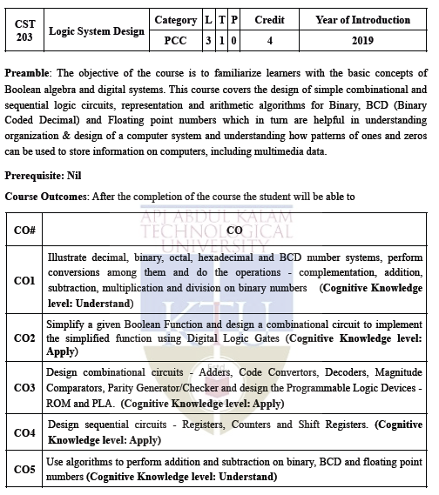

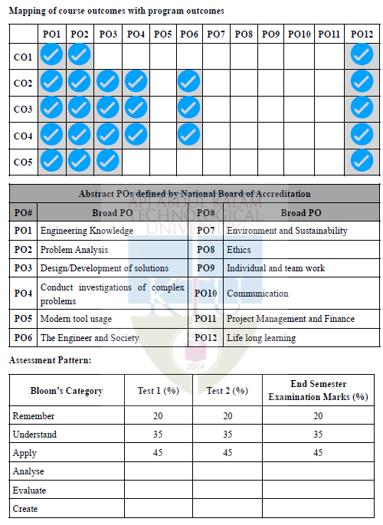
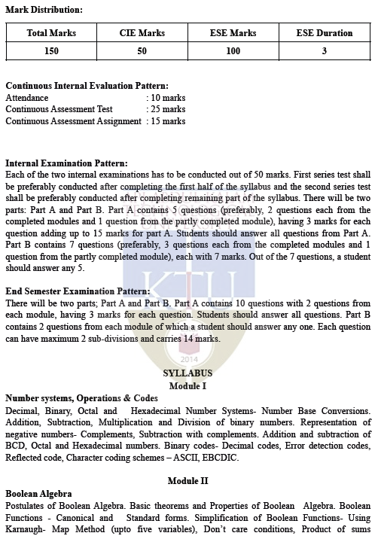
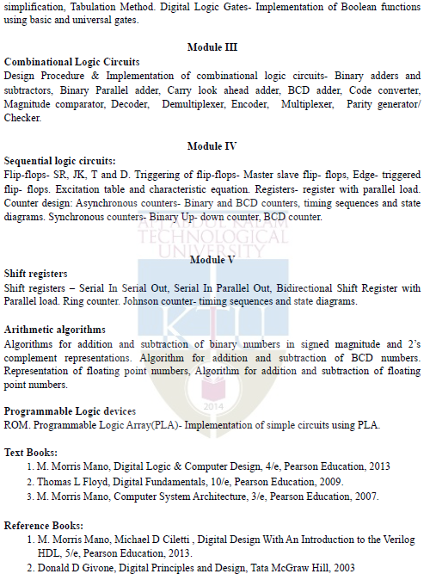

QUESTION BANK

MODULE I
Q:NO: | QUESTIONS | CO | KL | PAGE NO:
1 | Calculate the arithmetic operation +38 – 22 using 2’s complement method. | CO1 | K4 | 32
2 | Examine (422.875)10 in binary and Hex form. | CO1 | K4 | 16
3 | Calculate the arithmetic subtraction (110.111)2 from (1010.01)2 | CO1 | K4 | 25
4 | Examine the following numbers:  (i)(101111111.1101)2 to decimal (ii) (534.625)10 to binary | CO1 | K4 | 13
5 | Calculate the arithmetic operation +38 – 22 using 2’s complement method. | CO1 | K4 | 15
6 | Examine (242.875)10 in binary and Hex form. | CO1 | K4 | 18
7 | Calculate the arithmetic subtraction (111.111)2 from (1110.01)2 | CO1 | K4 | 22
8 | Calculate arithmetic operation (CD812)16 + (54216)16 | CO1 | K4 | 18
9 | Examine (325.25)10 in binary number system. | CO1 | K4 | 19
MODULE II
1 | Generate the minimal SOP expression F= (AB)’+ A’B’+ A’B’C’. | CO2 | K5 |  | 35
2 | Generate the minimal SOP expression for F= ∑ m (1,5,7,8,9,10,11,14,15) and implement it using NOR logic. | CO2 | K5 |  | 44
3 | Generate the minimal SOP expression for F= ∑ m (2, 3, 5, 7, 9, 11, 12, 13, 14, 15) and implement it using NAND logic. | CO2 | K5 |  | 47
4 | Generate the minimal SOP expression for F(A, B, C, D)=∏M(0,1,3,5,6,7,10,14,15) | CO2 | K5 |  | 50
5 | State and prove De Morgan’s laws. | CO2 | K1 |  | 36
6 | Generate the minimal SOP expression A’B’+ A’B+ AB. | CO2 | K5 |  | 42
7 | Develop the expression F=A+BC’+ABD’+ABCD to minterm and maxterm. | CO2 | K5 |  | 49
MODULE III
1 | Define combinational logic circuit. Explain the steps for designing combinational logic circuit | CO3 | K1 |  | 53
2 | Evaluate the truth table for a full subtractor. Reduce it using k-map. Implement it using logic gates, NAND logic and NOR logic. | CO3 | K6 |  | 60
3 | Evaluate the truth table for a half adder. Reduce it using k-map. Implement it using logic gates, NAND logic and NOR logic. | CO3 | K6 |  | 62
4 | Evaluate the truth table for a full adder. Reduce it using k-map. Implement it using logic gates, NAND logic and NOR logic. | CO3 | K6 |  | 65
5 | Evaluate the truth table for a half subtractor. Reduce it using k-map. Implement it using logic gates, NAND logic and NOR logic. | CO3 | K6 |  | 67
6 | Evaluate the truth table for a full subtractor. Reduce it using k-map. Implement it using logic gates. | CO3 | K6 |  | 58
MODULE IV
1 | Design a gray to binary decoder. Write down the truth table, expressions and show the hardware implementation. | CO4 | K5 |  | 69
2 | Construct a 4 x 1 Multiplexer and realise the Boolean expression. | CO4 | K5 |  | 71
3 | Design a BCD adder circuit. | CO4 | K5 |  | 73
4 | Design a binary to gray decoder. Write down the truth table, expressions and show the hardware implementation. | CO4 | K5 |  | 74
5 | Construct a 1 x 4 demultiplexer and realise the Boolean expression. | CO4 | K5 |  | 75
6 | Compare combinational and sequential circuits. | CO4 | K4 |  | 76
7 | Compare encoder and decoder circuits. | CO4 | K4 |  | 71
8 | Discuss about race around condition. How can it be avoided? | CO4 | K2 |  | 70
9 | Compare asynchronous and synchronous counters. | CO4 | K4 |  | 74
10 | Design a 2 bit Magnitude comparator circuit. | CO4 | K5 |  | 75
MODULE V
1 | Construct a 4-bit Ring counter and Johnson counter. Draw the Truth Table and the waveforms. | CO5 | K5 |  | 81
2 | Compare 4-bit serial-In-Parallel-out shift register and 4-bit parallel-In-Parallel- out shift register. | CO5 | K4 |  | 83
3 | Explain the design procedure of a synchronous counter with an example. | CO5 | K2 |  | 85
4 | Compare 4-bit serial-In-serial-out shift register and 4-bit parallel-In-serial-out shift register. | CO5 | K4 |  | 89
5 | Explain the design procedure of a synchronous counter with an example. | CO5 | K2 |  | 91
6 | Compare 4-bit serial-In-serial-out shift register and 4-bit parallel-In-serial-out shift register. | CO5 | K4 |  | 93
7 | Design a Mod 6 Synchronous counter. Enumerate all the steps in the design. | CO5 | K5 |  | 92
8 | Sketch the logical diagram of a 4-bit ring counter using D flip flop. | CO5 | K3 |  | 94
9 | Design a Mod 6 Synchronous counter. Enumerate all the steps in the design. | CO5 | K5 |  | 91
10 | Sketch the logical diagram of a 4-bit ring counter using D flip flop. | CO5 | K3 |  | 94

MODULE NOTES
.MODULE I

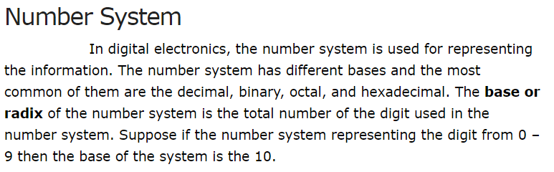
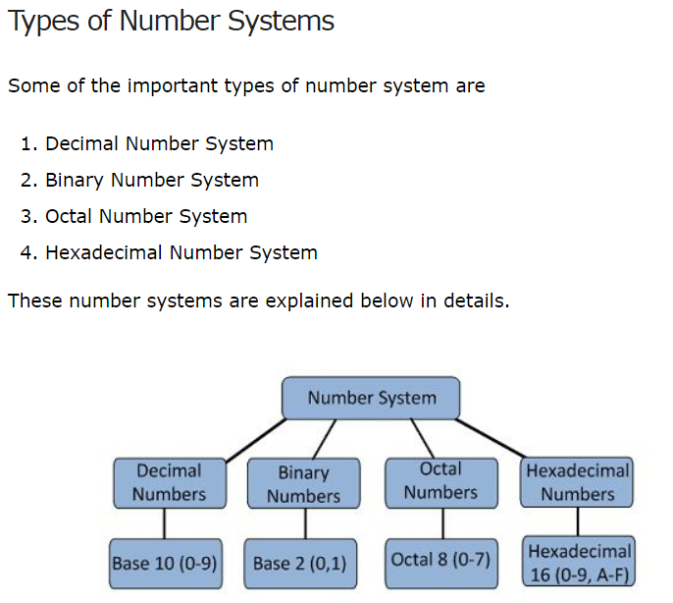
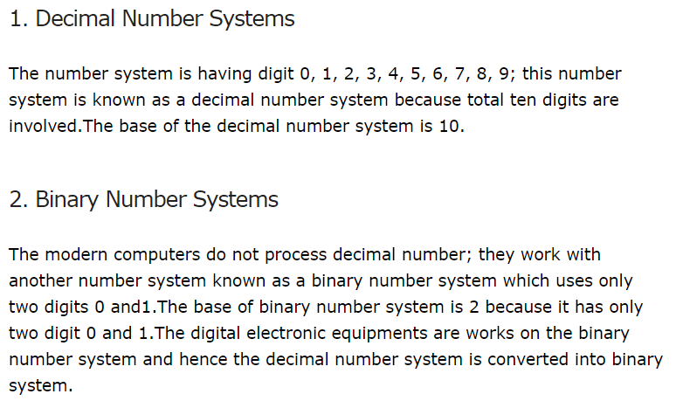

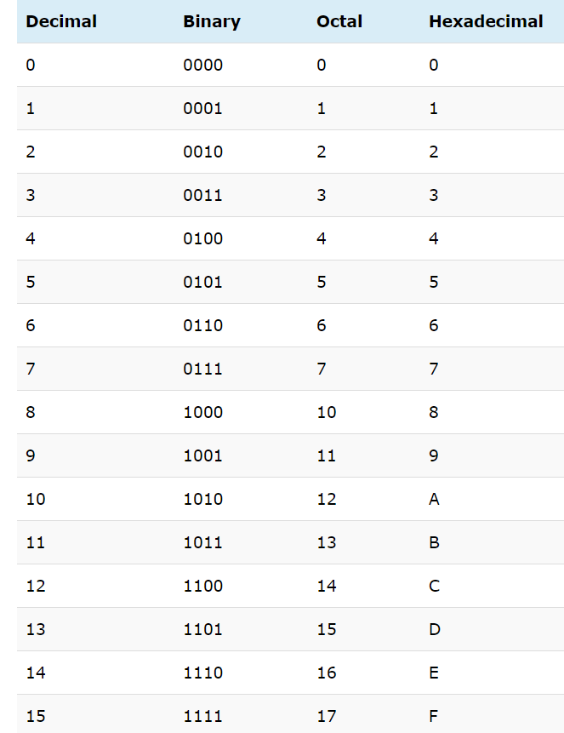
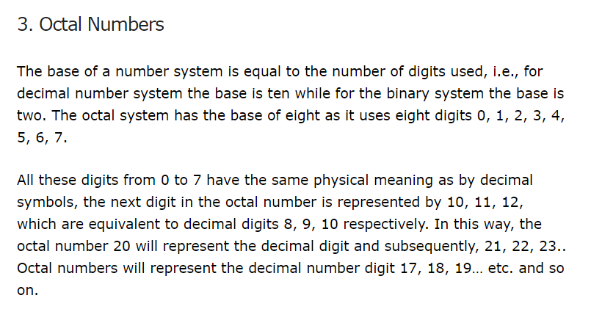
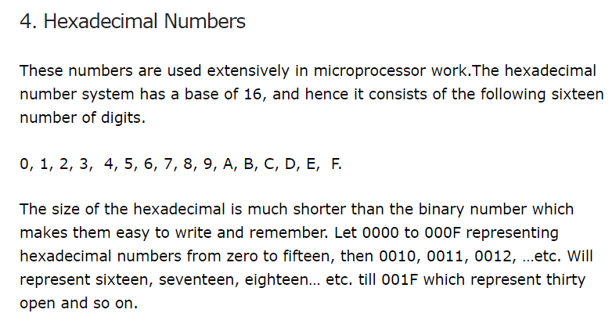

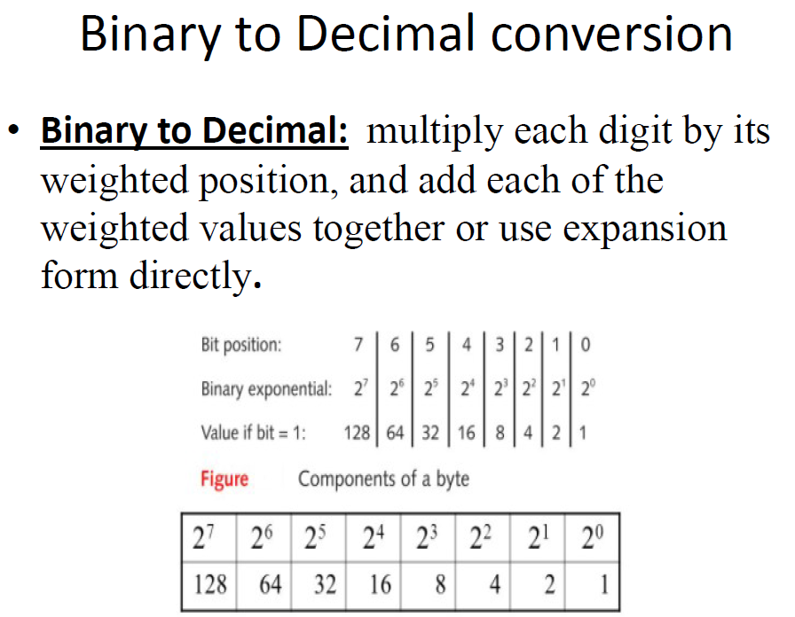
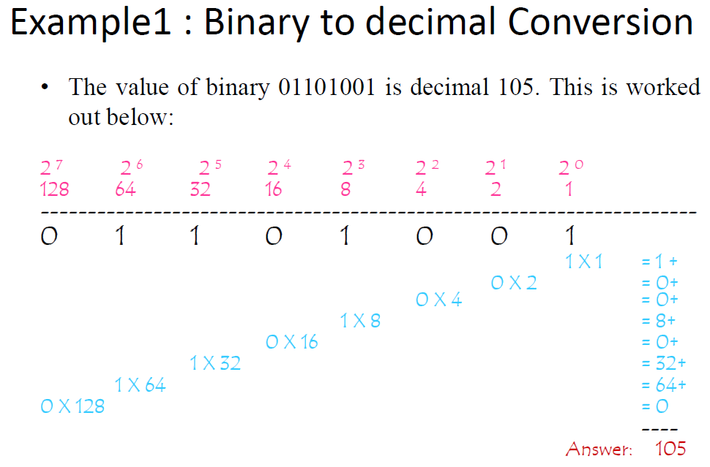
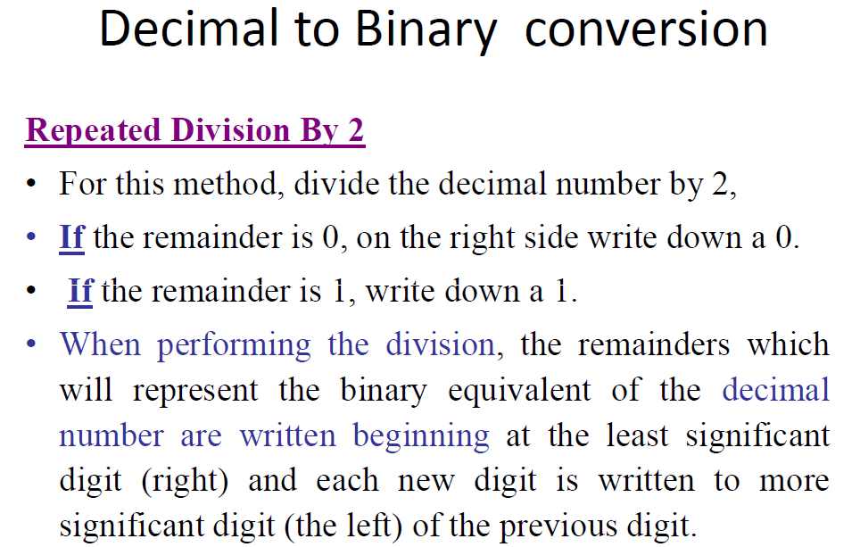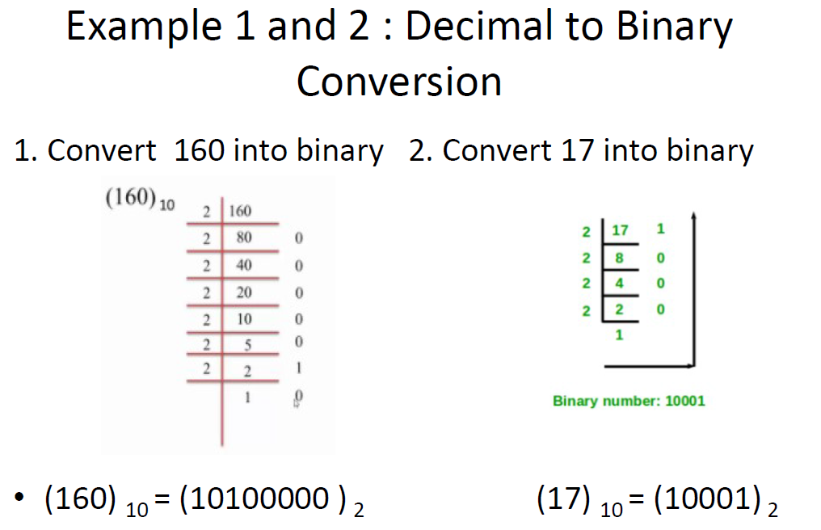
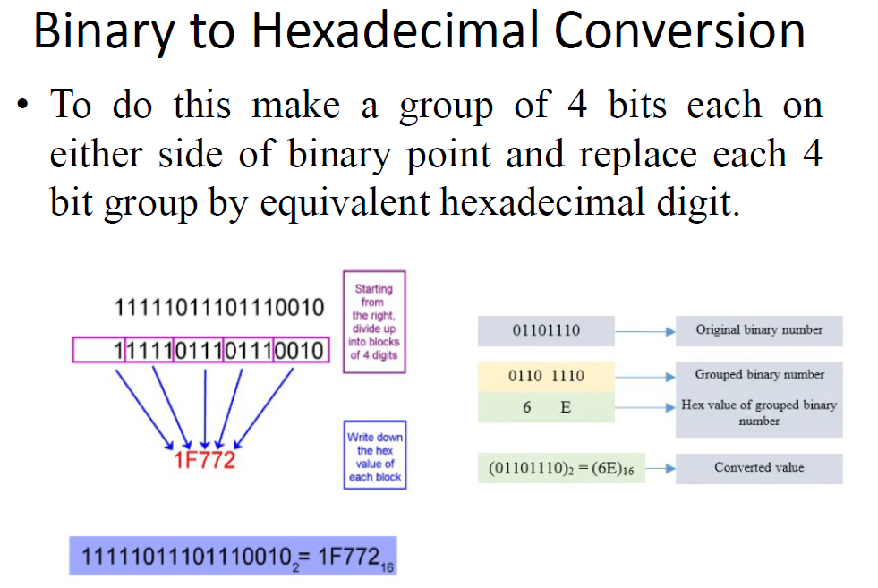
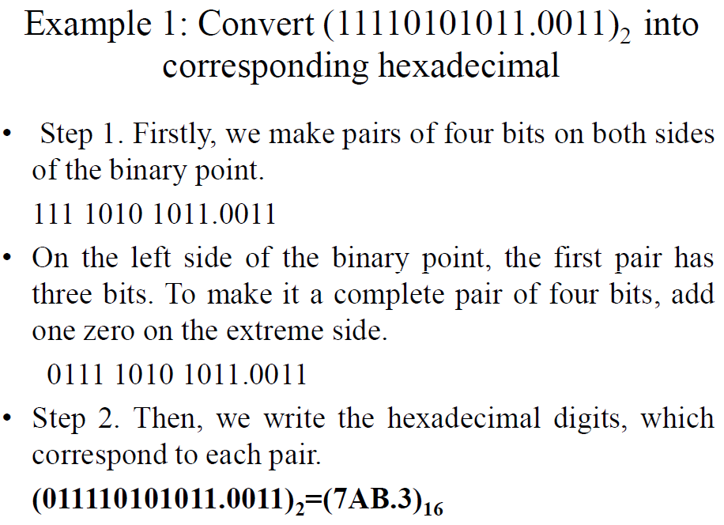
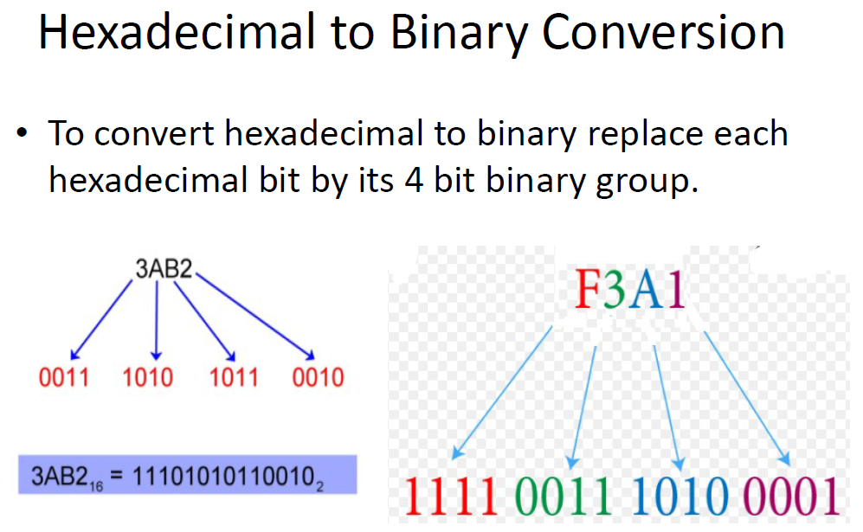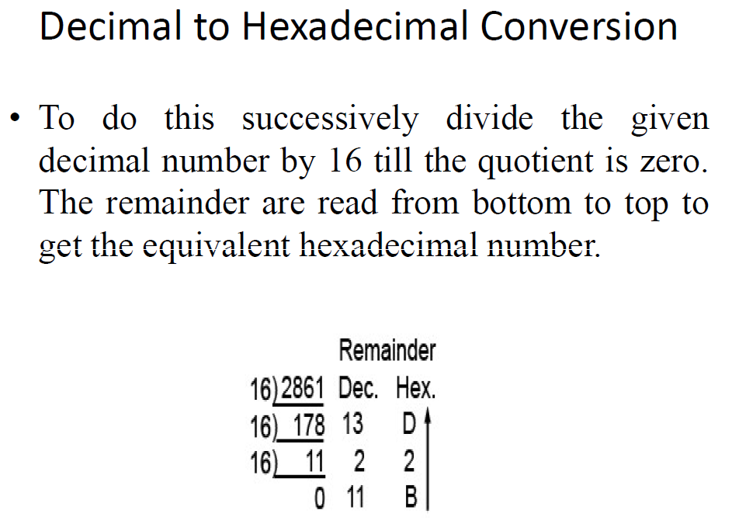
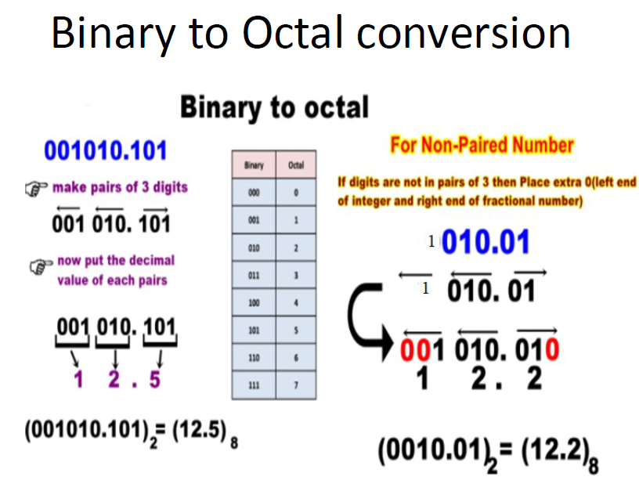
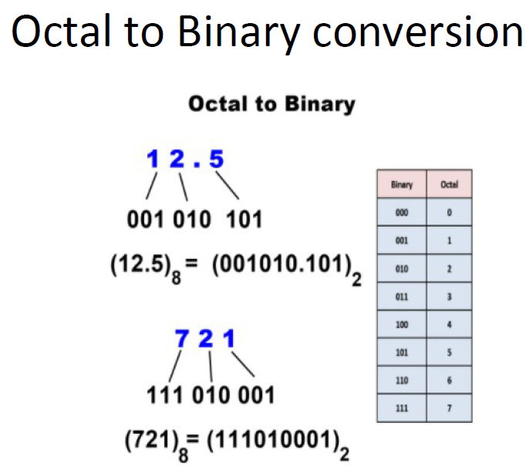
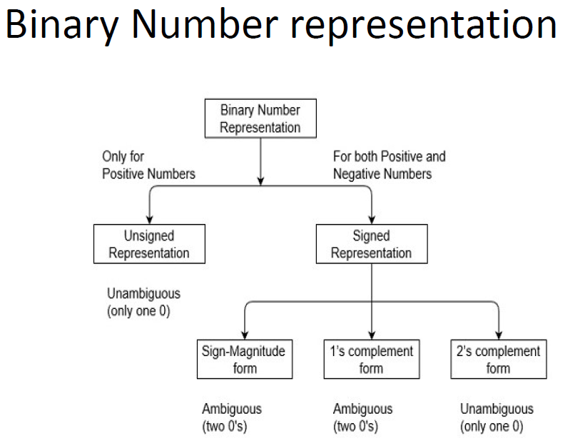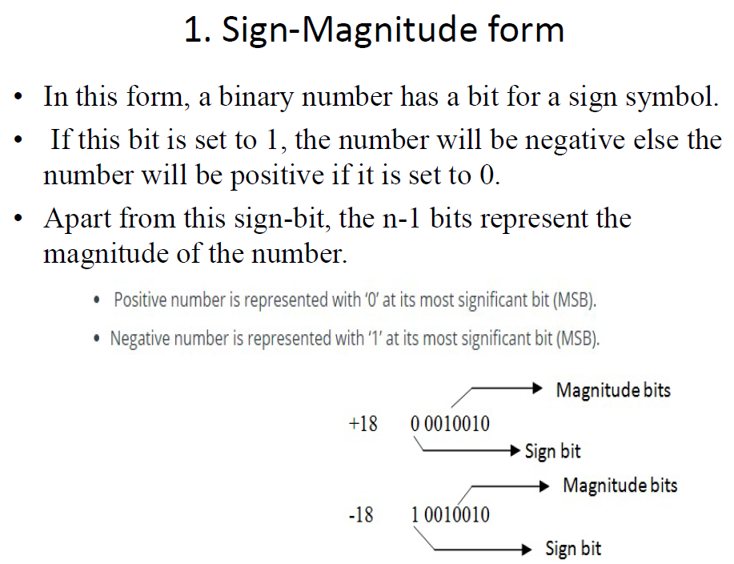

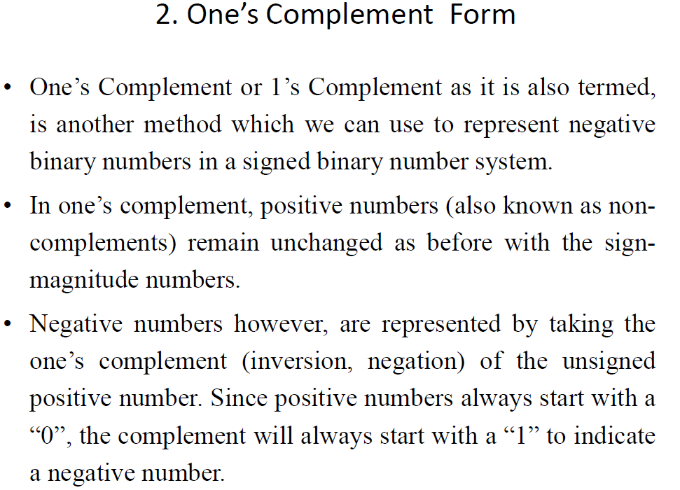
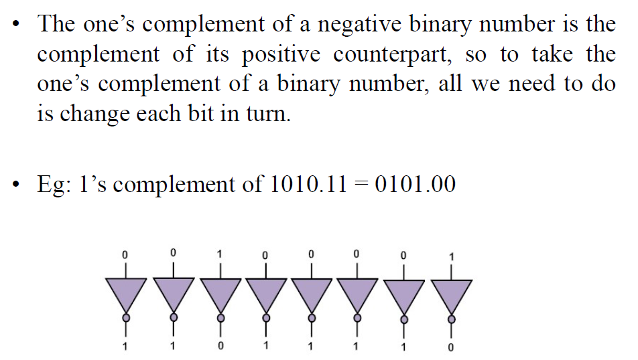
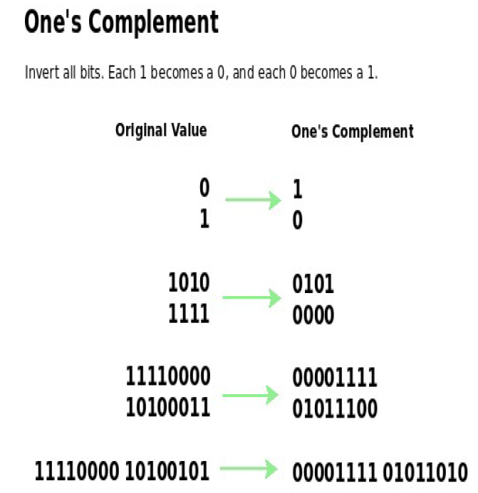
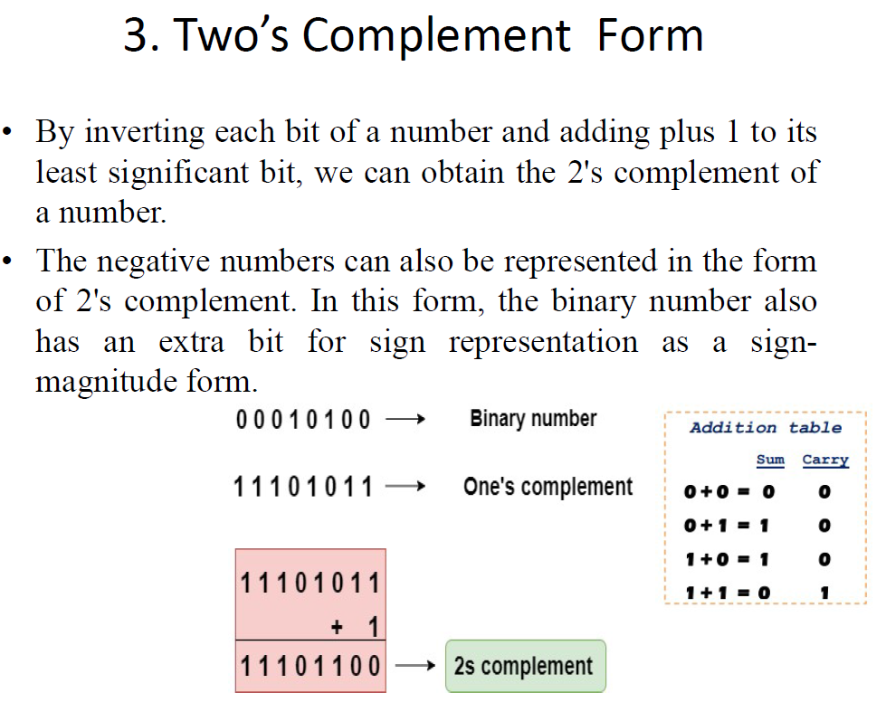
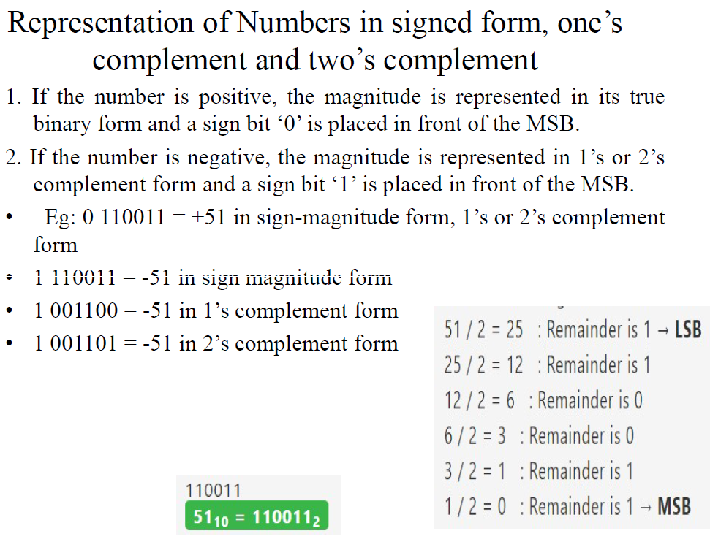
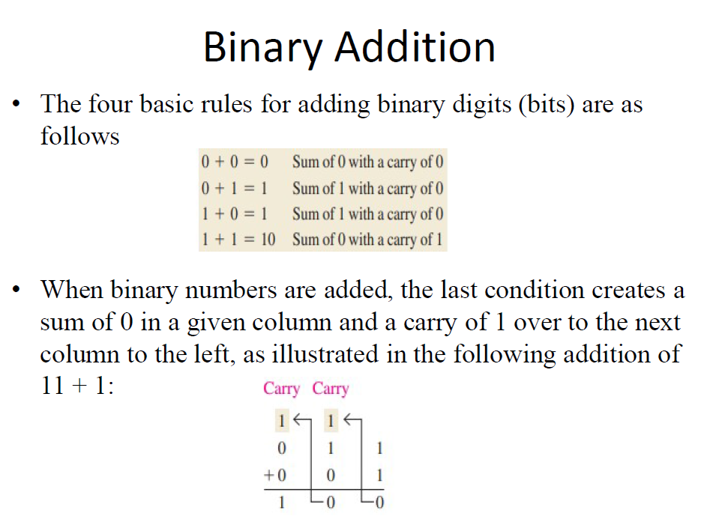
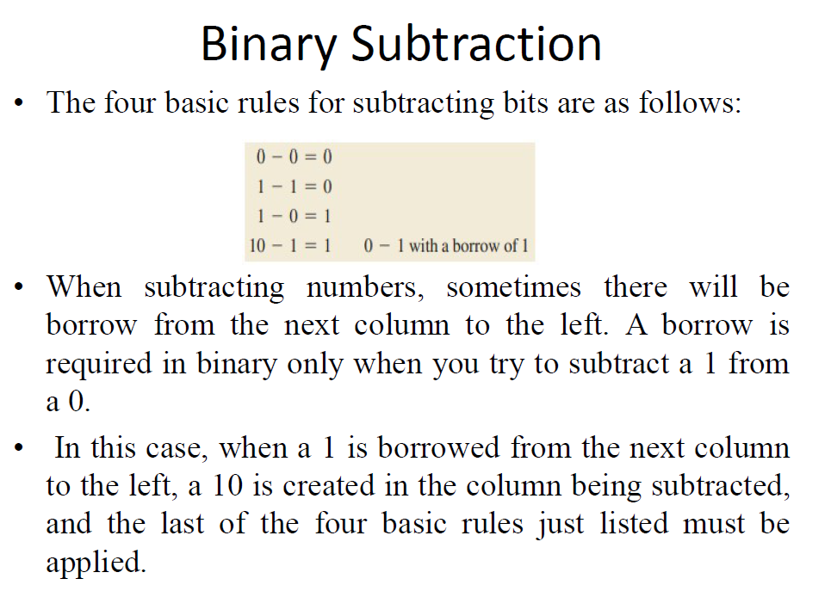
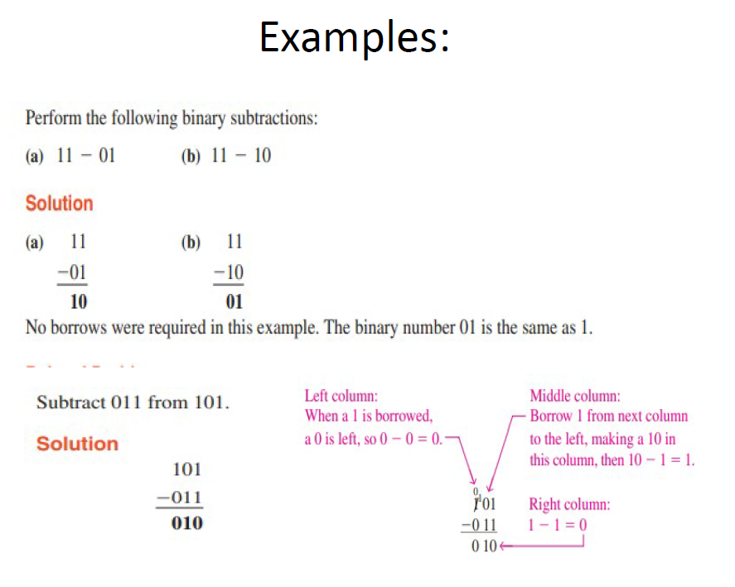
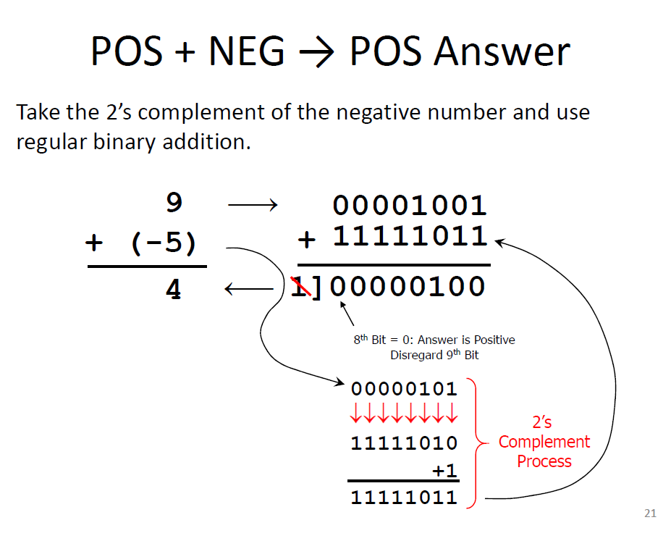
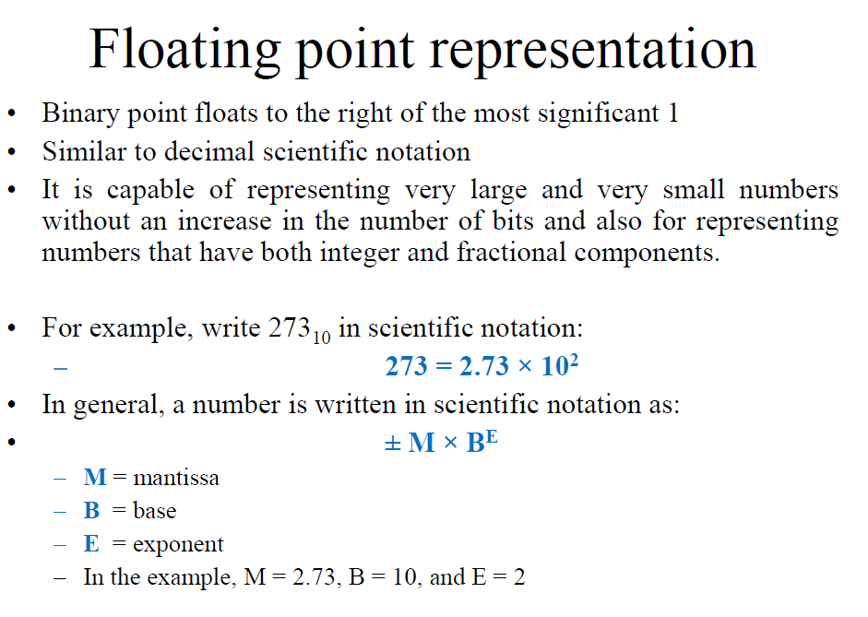
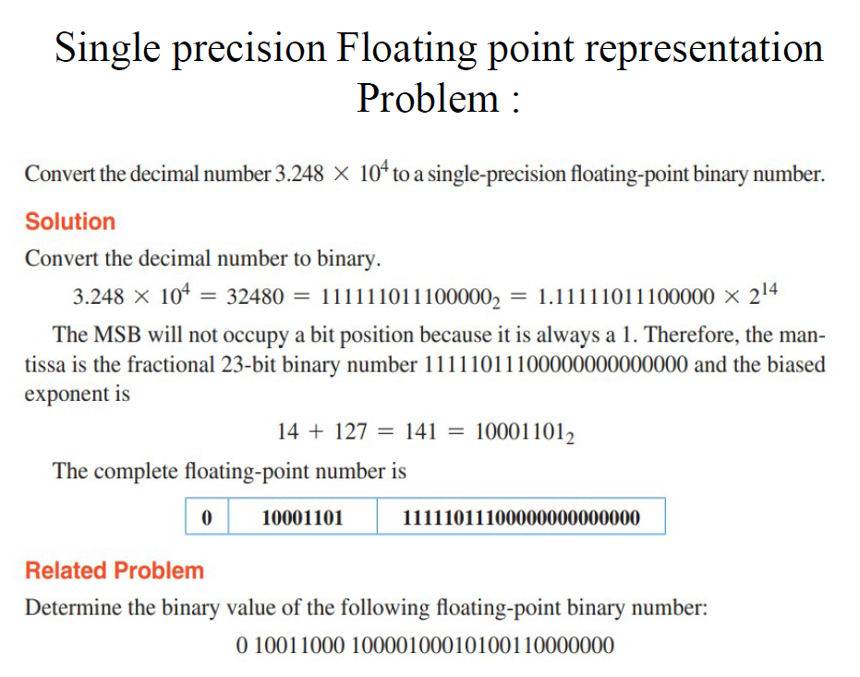
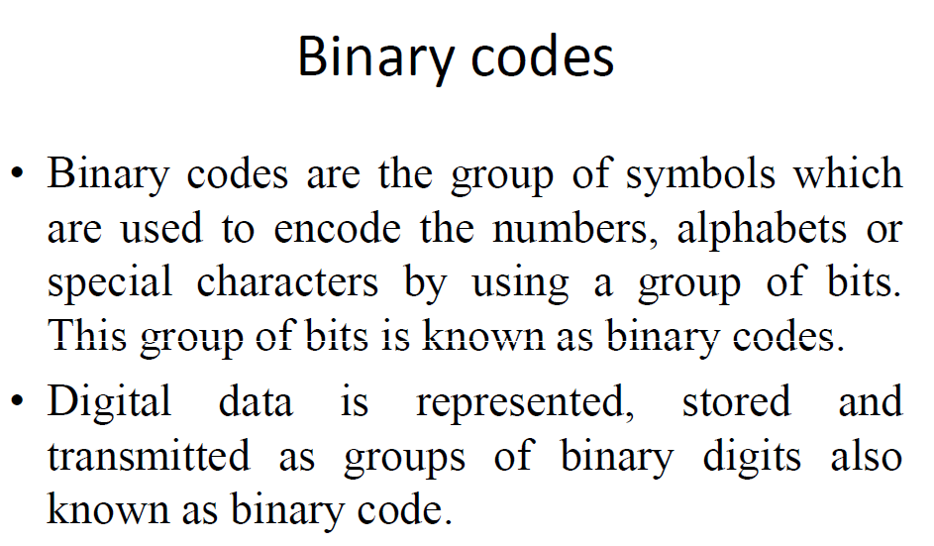
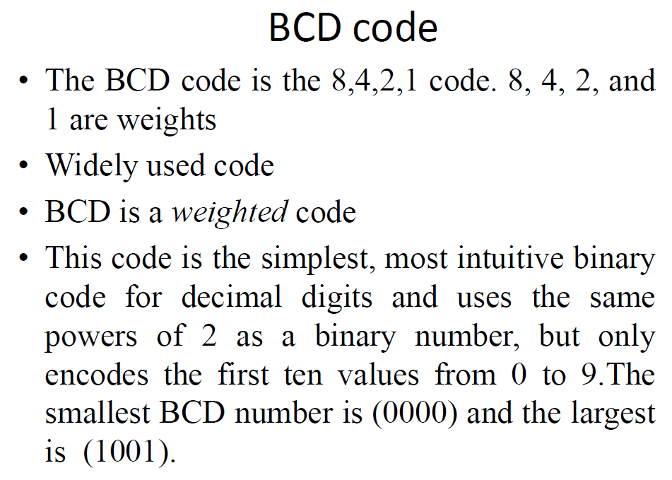
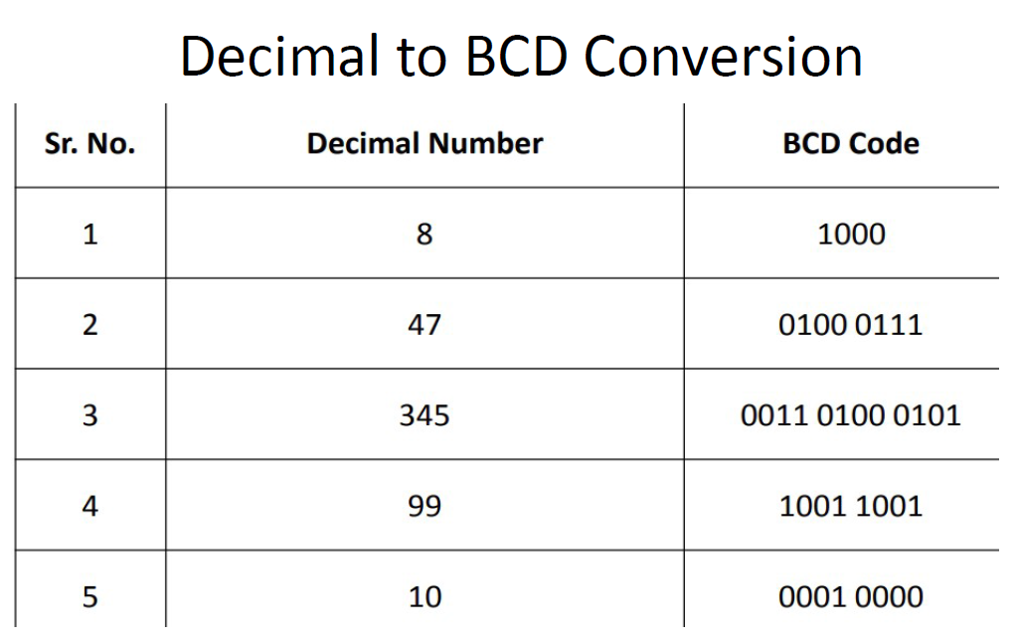
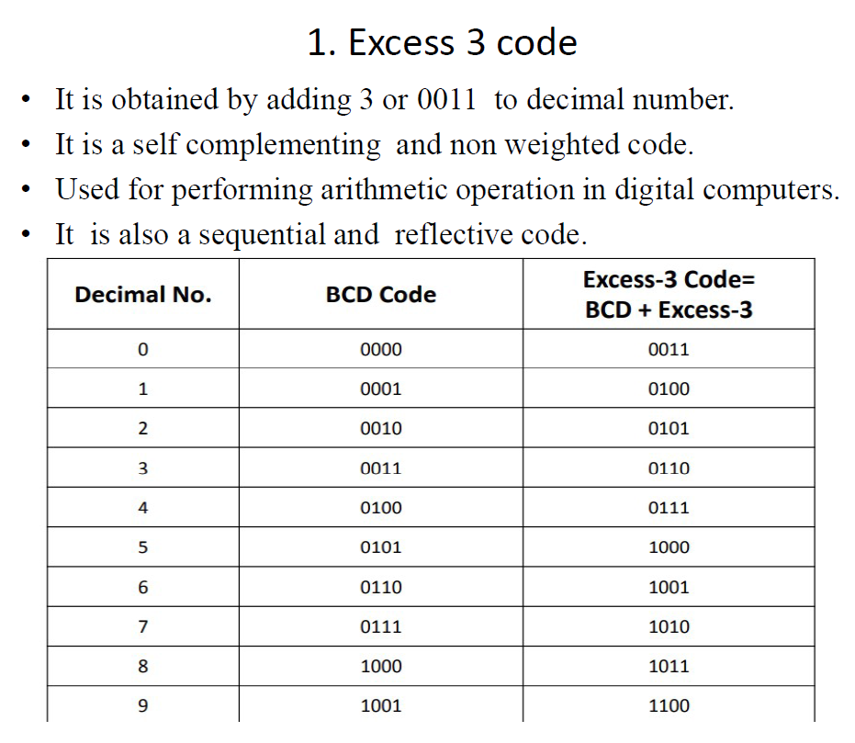
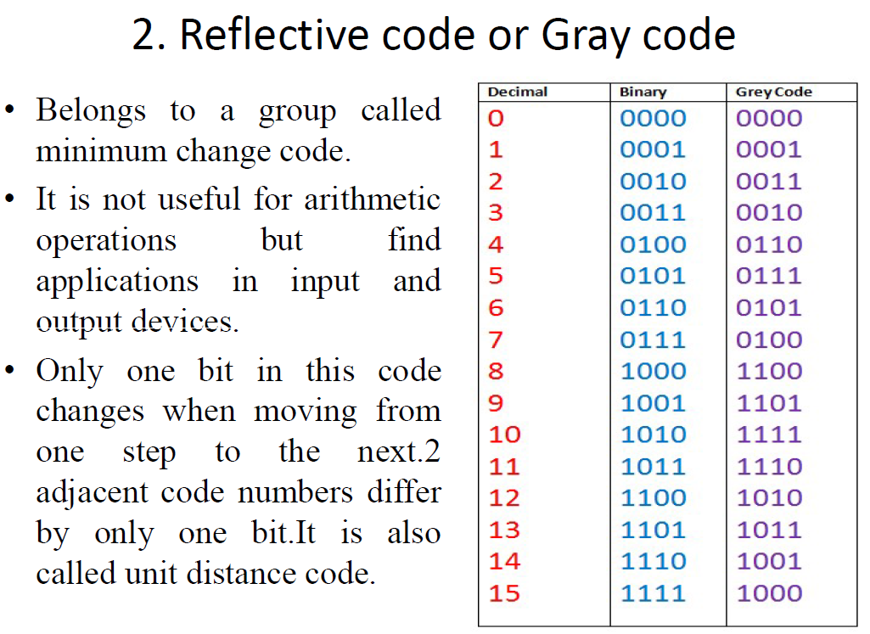
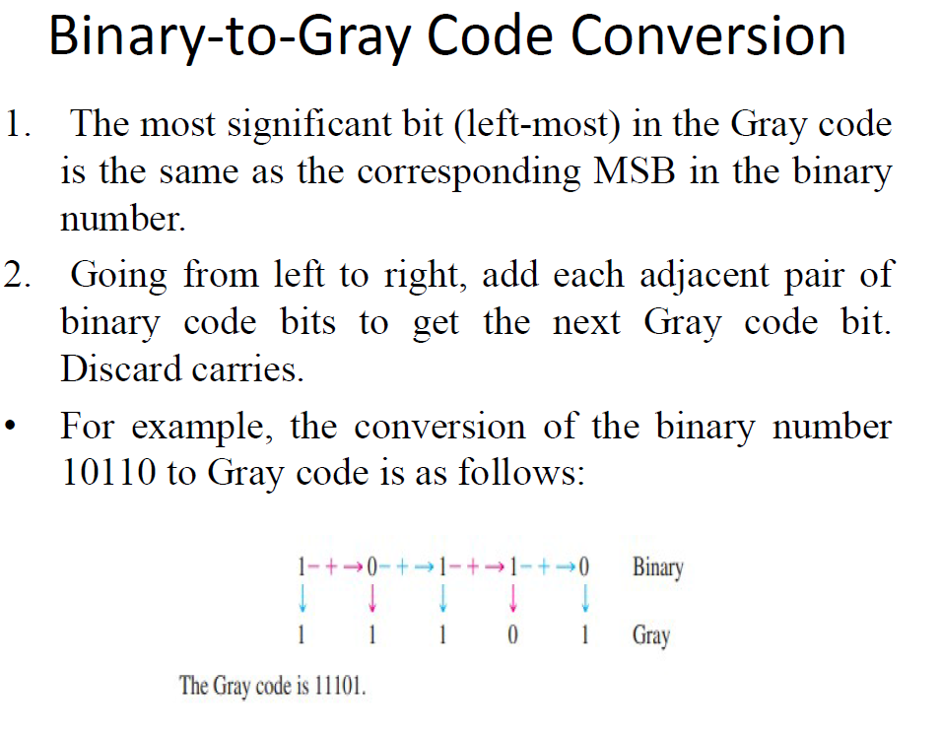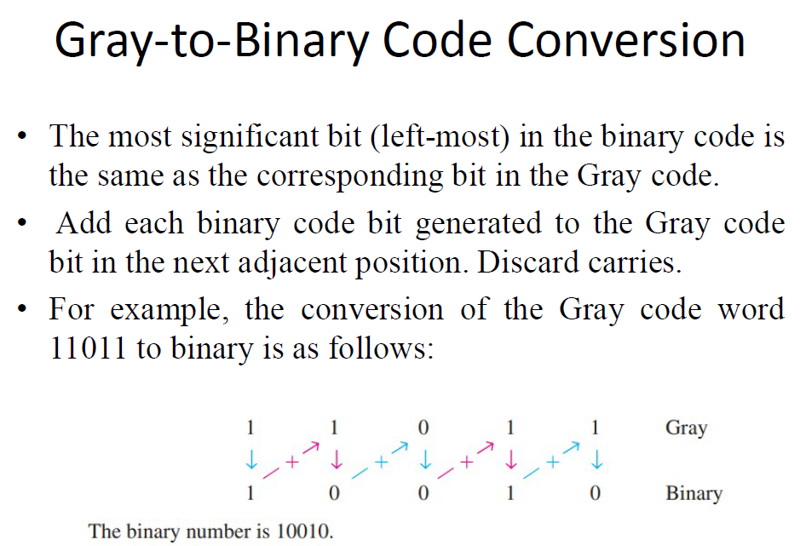
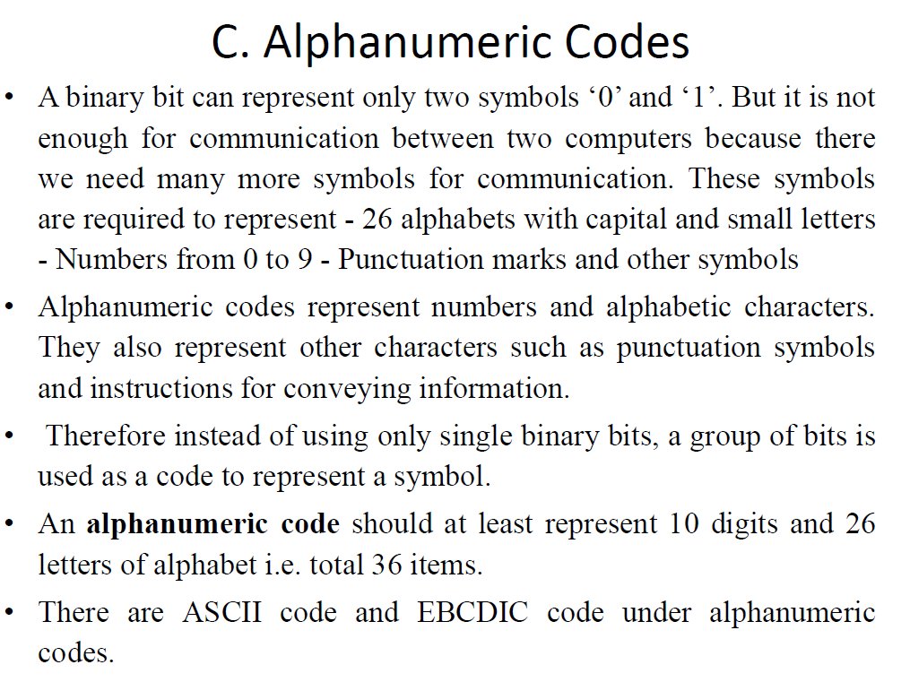

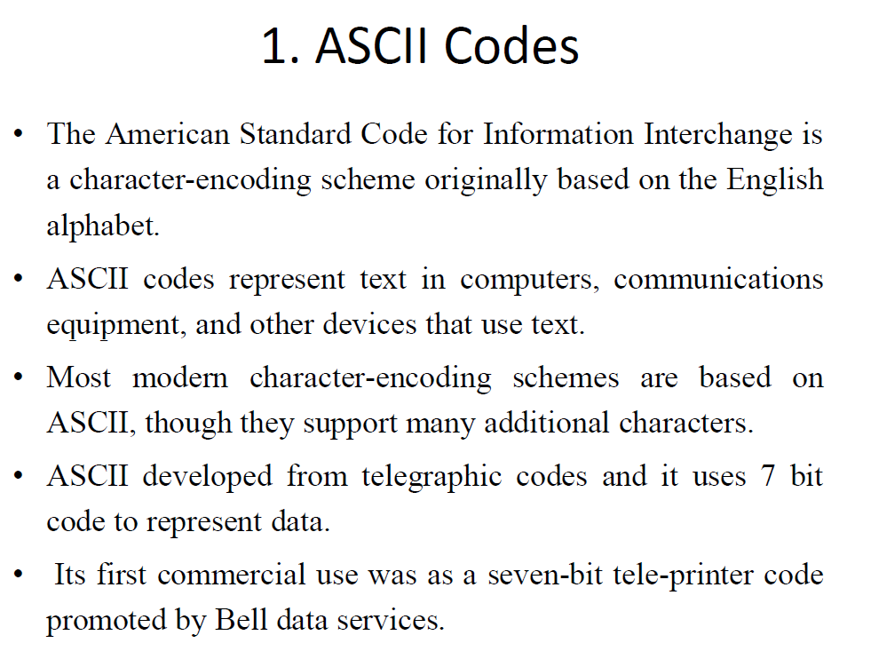
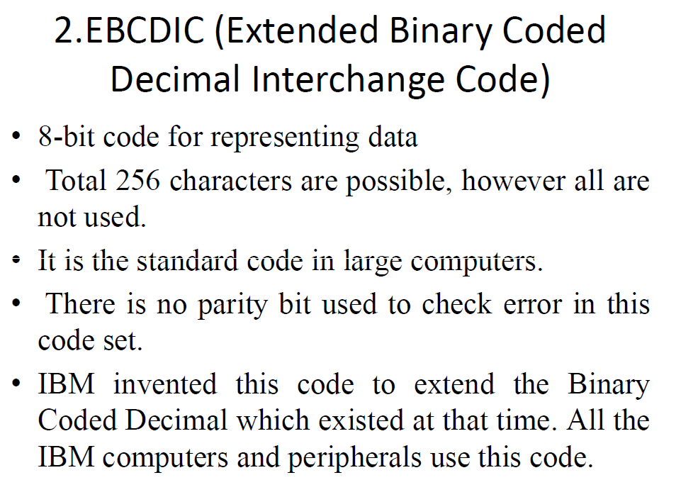

MODULE II

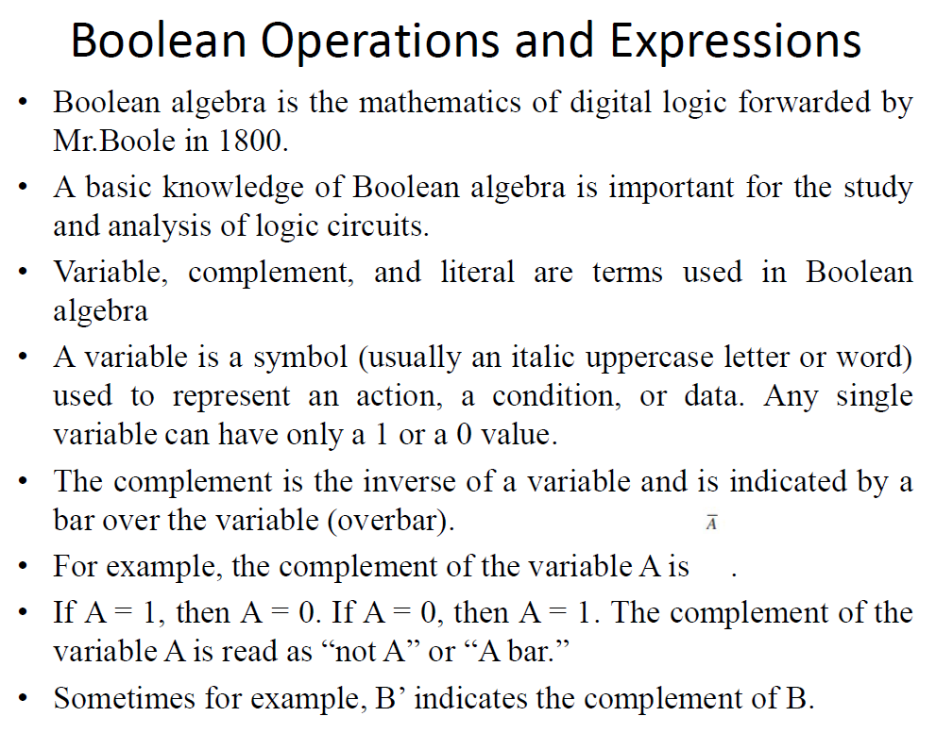
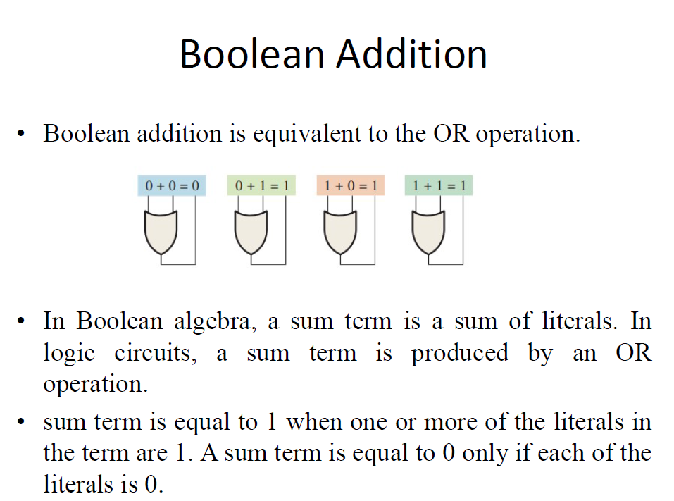
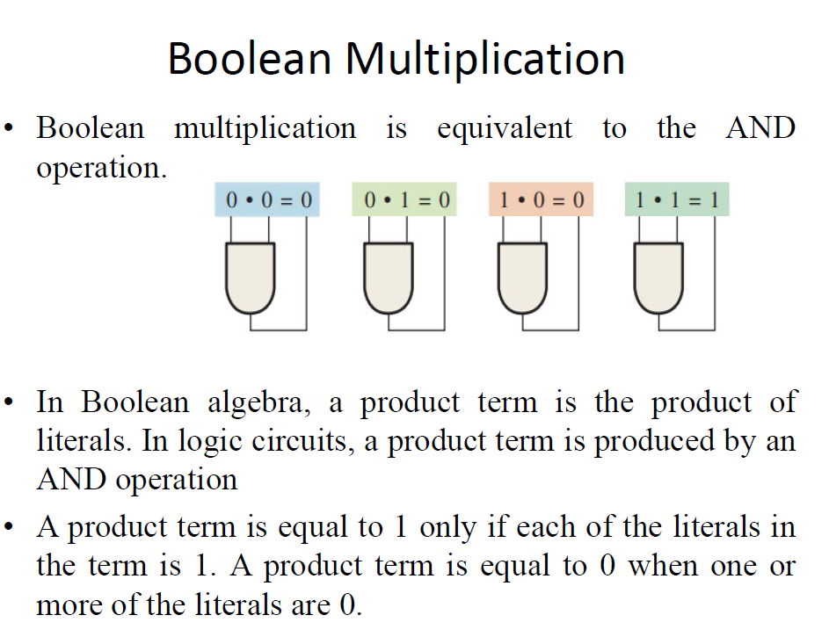
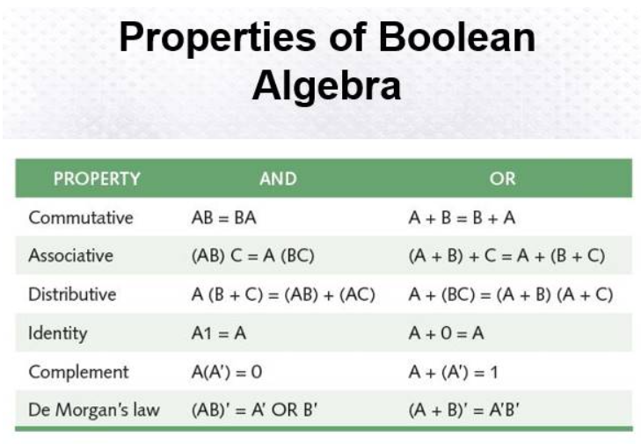

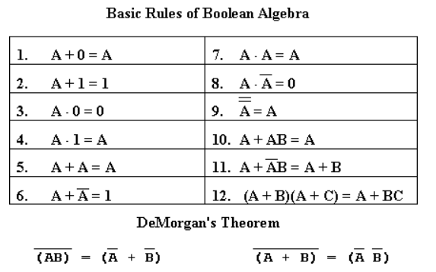
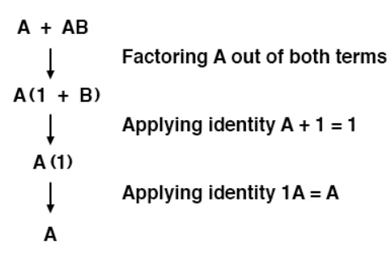
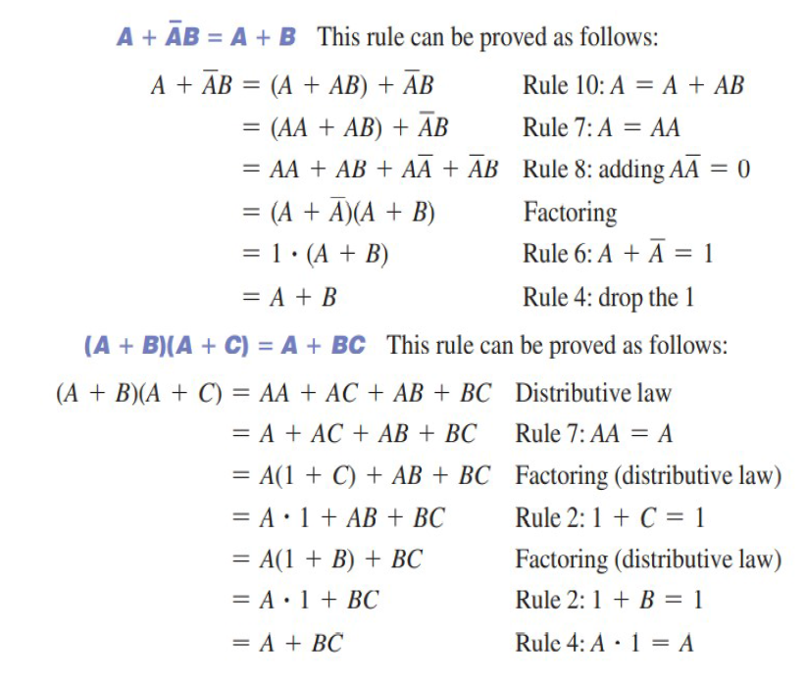
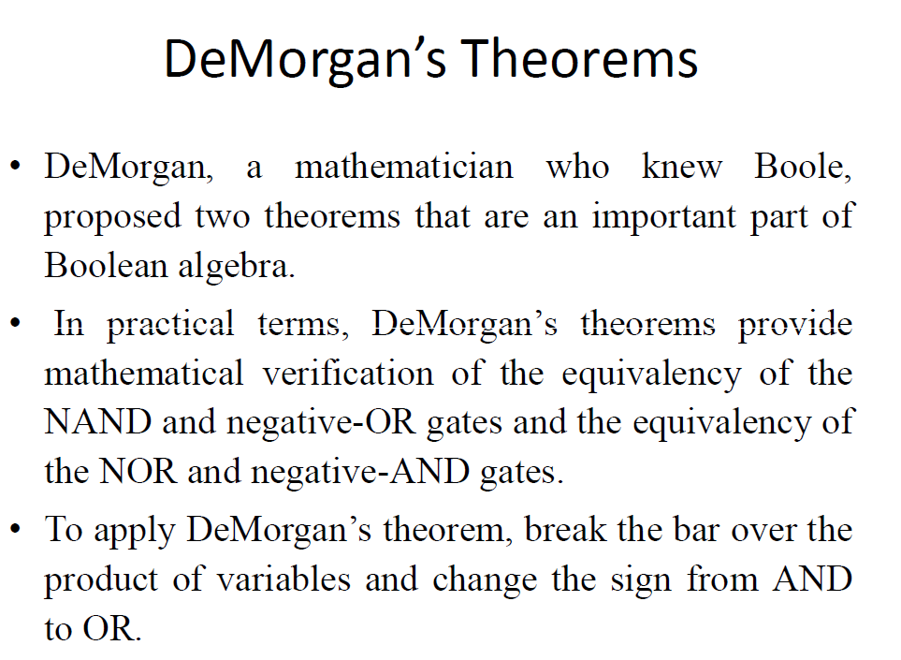
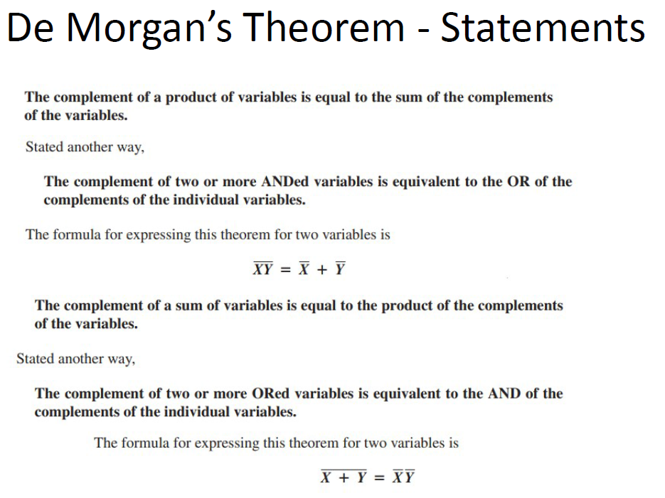
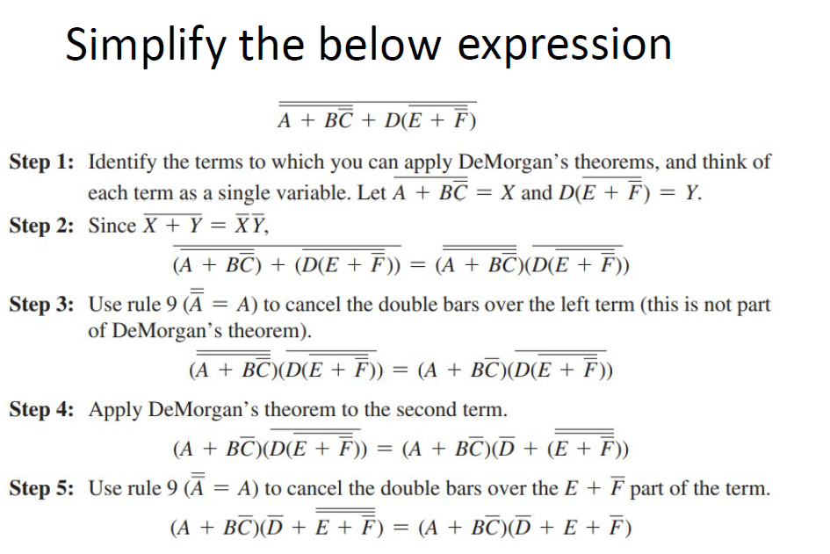
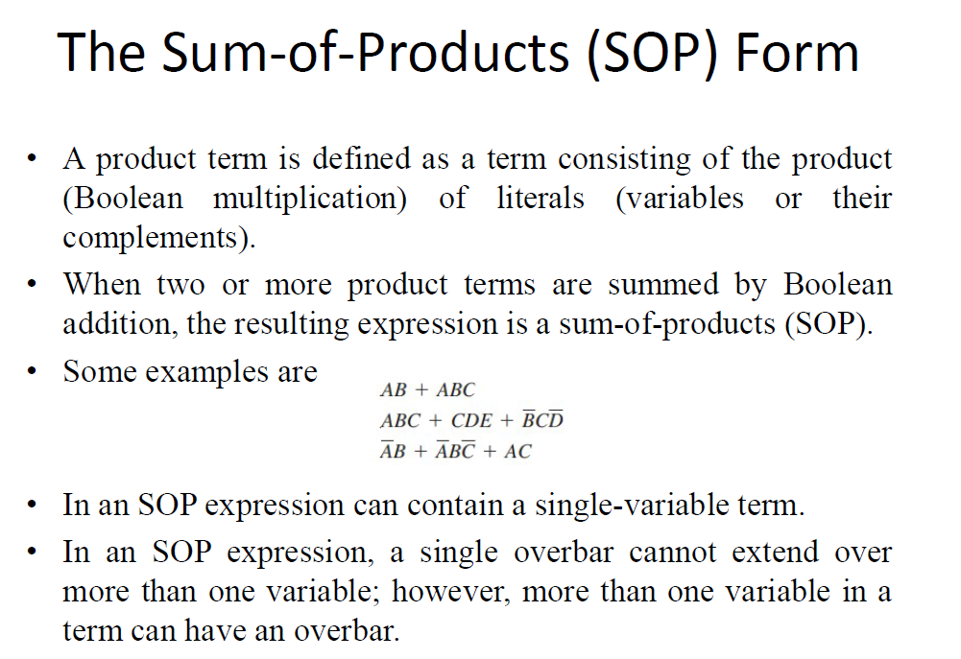
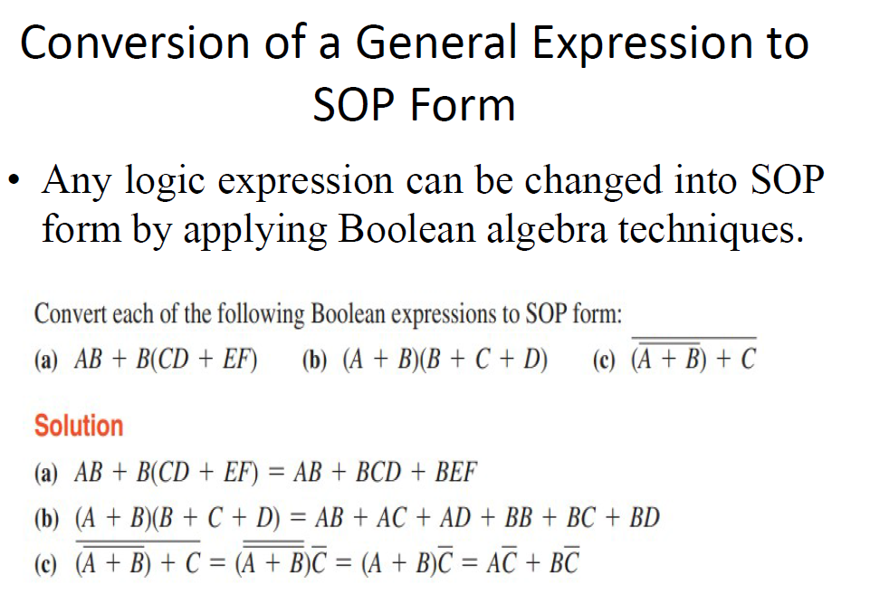
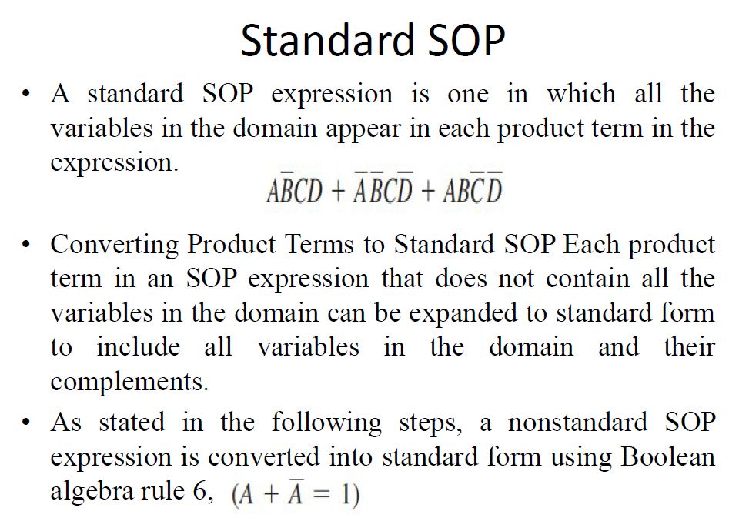
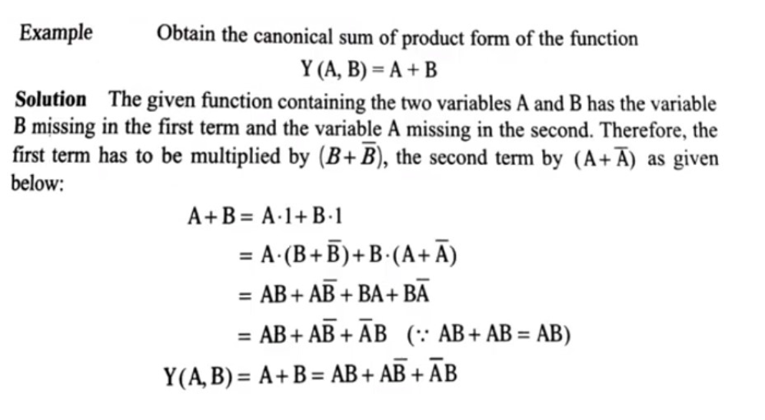

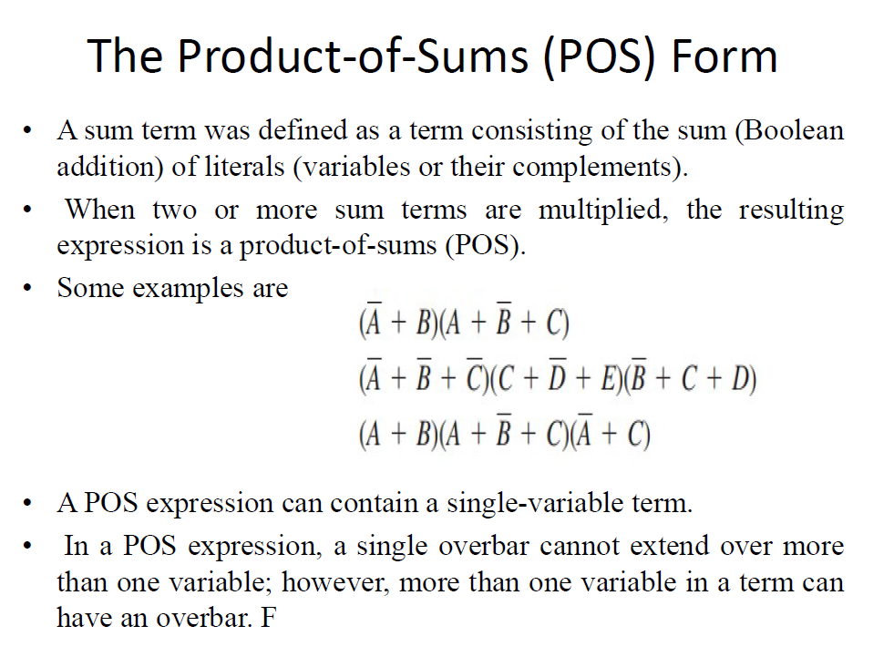
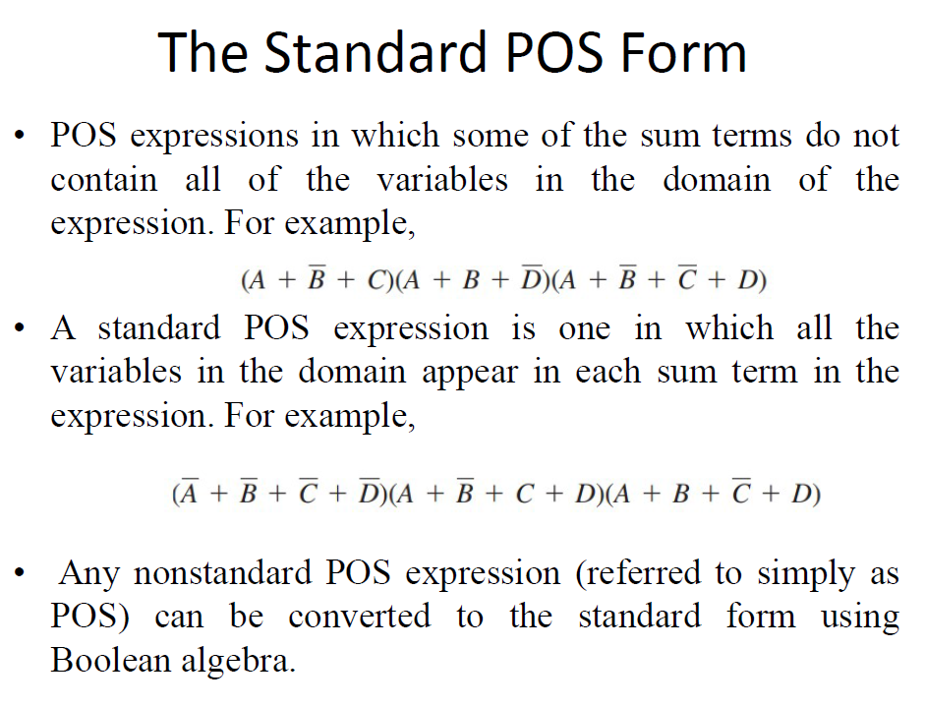
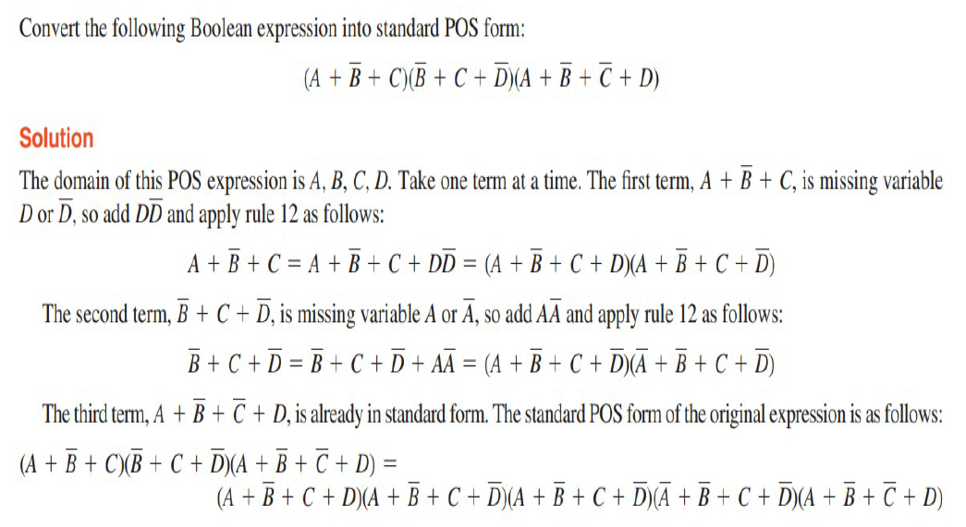
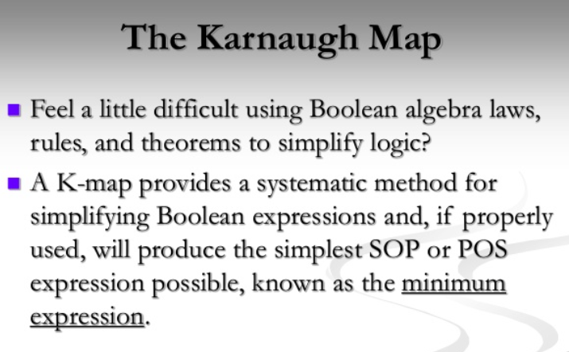
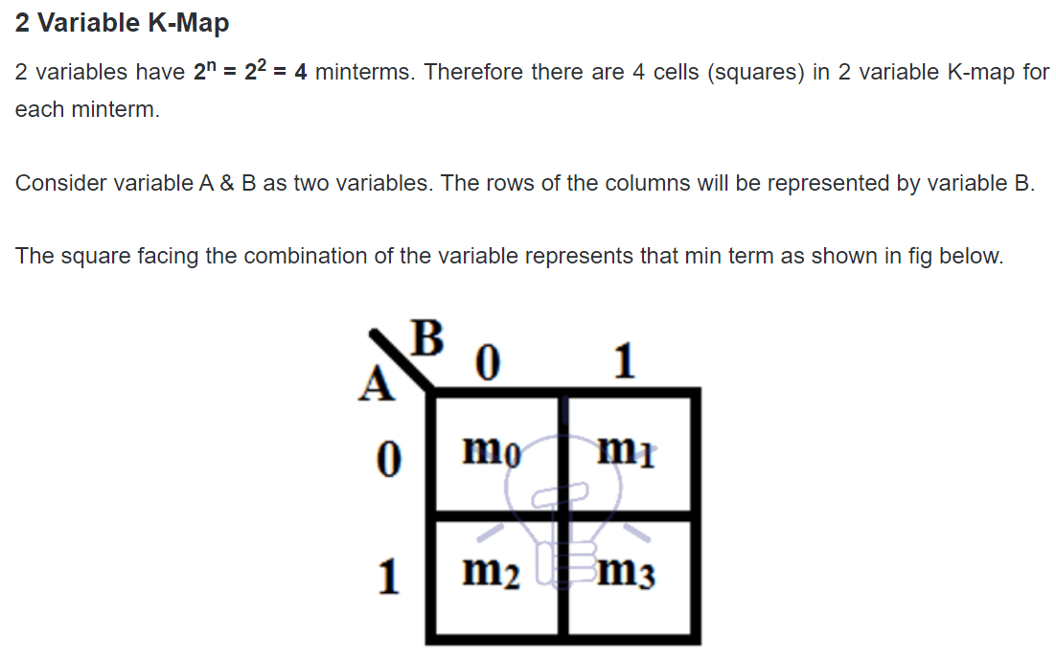
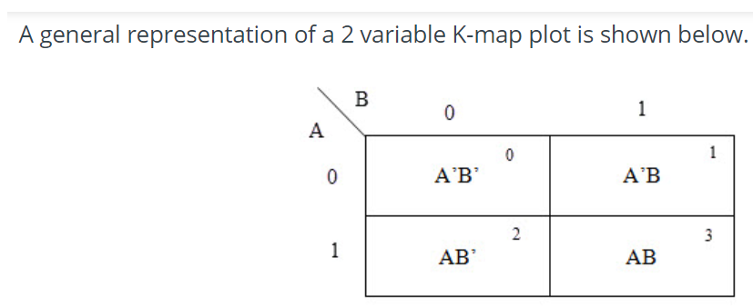
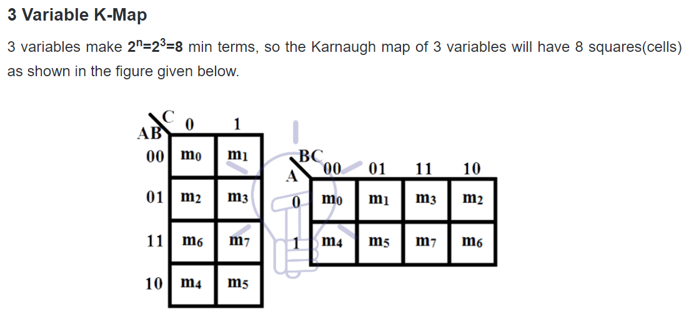
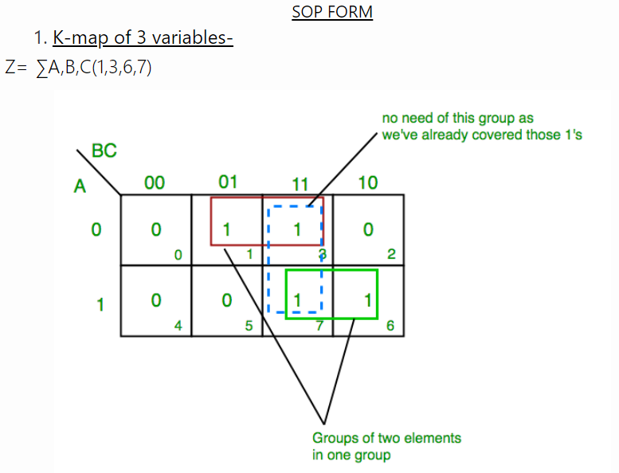
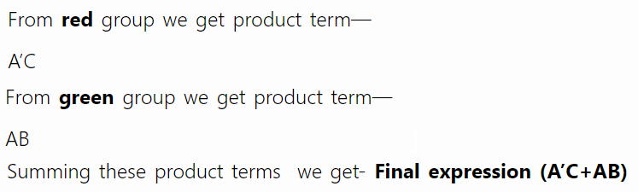
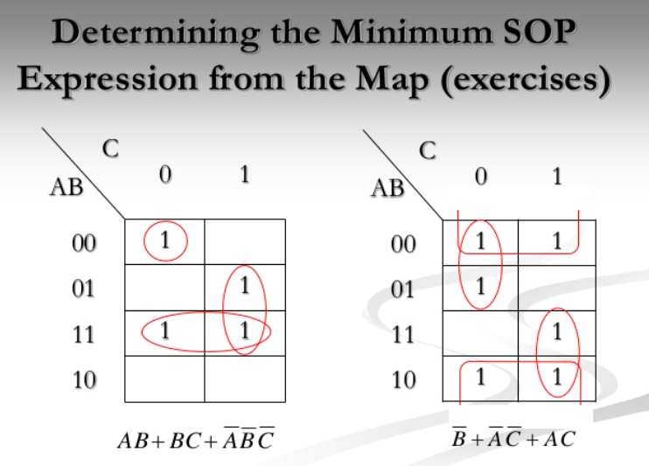
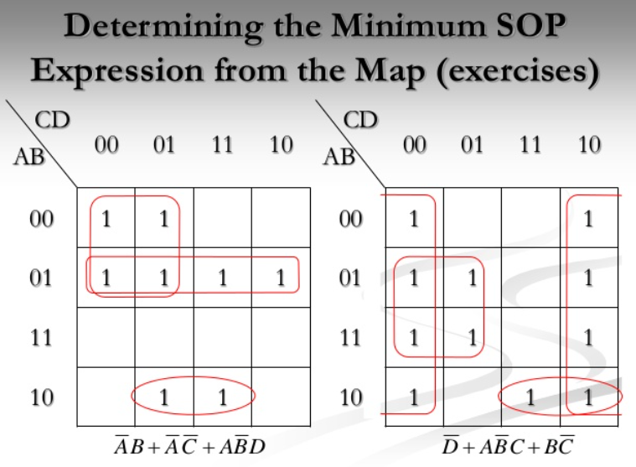
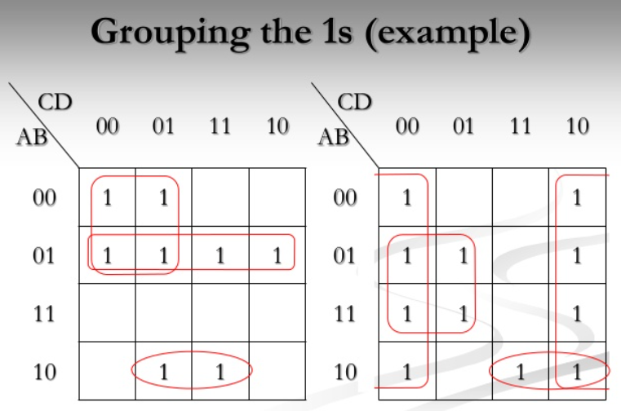
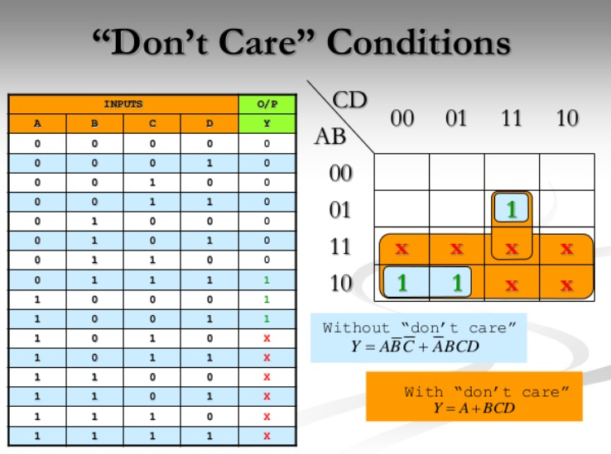
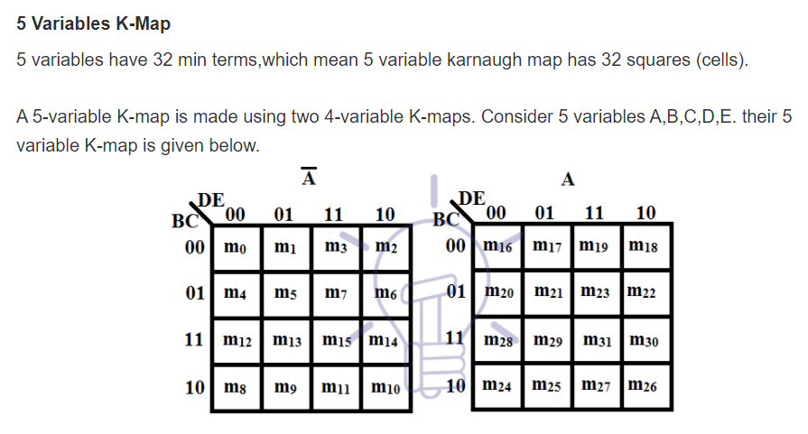
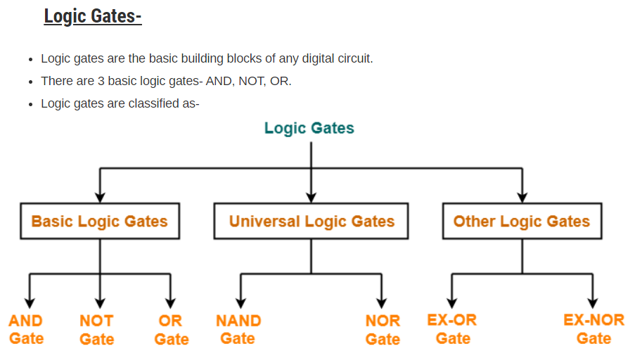
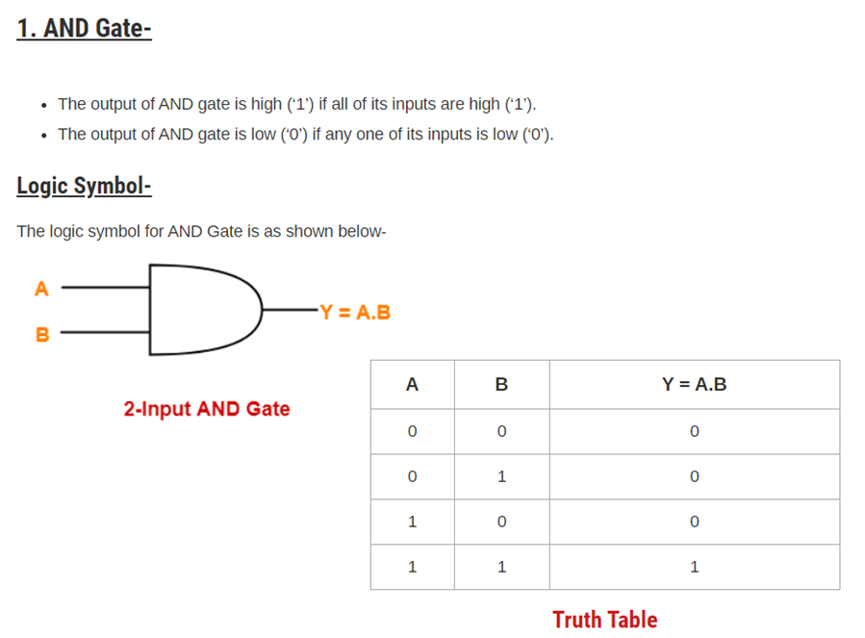
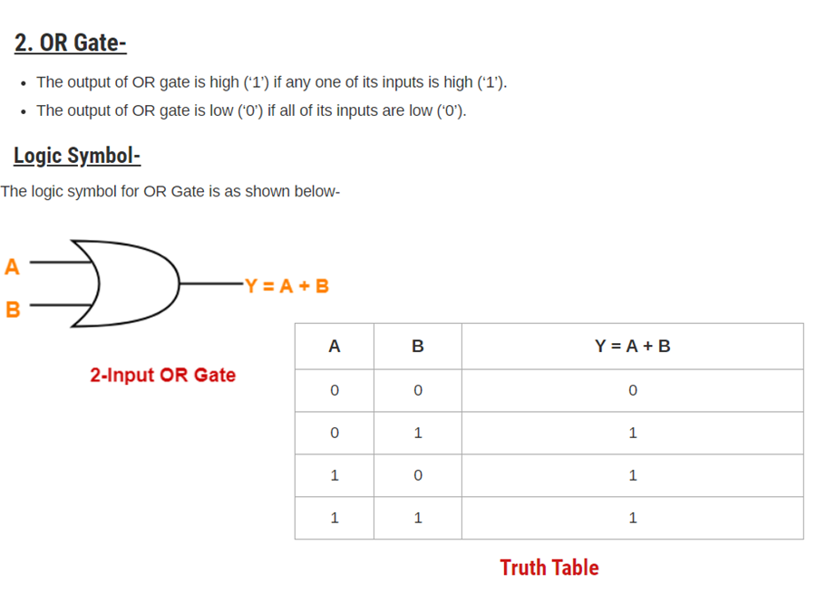
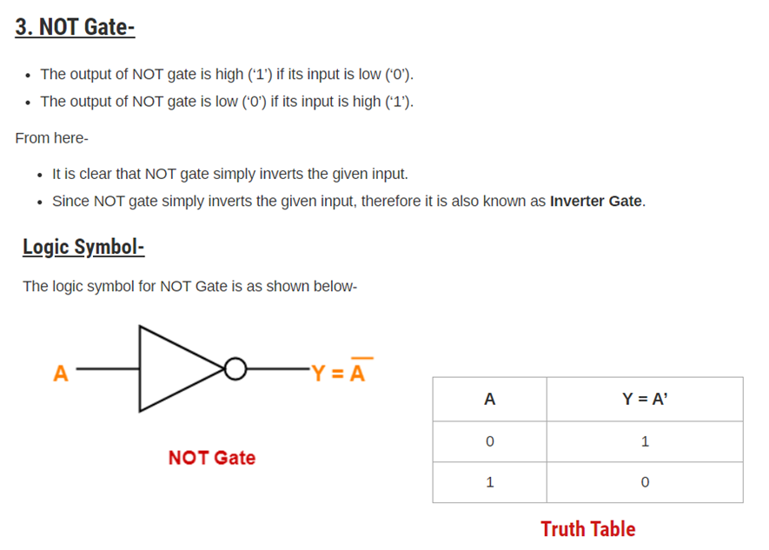
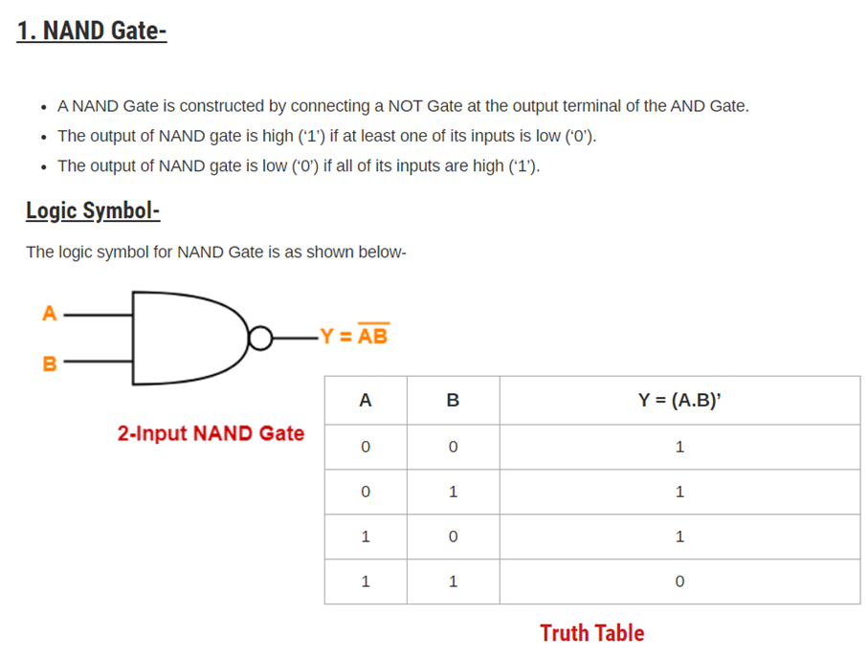
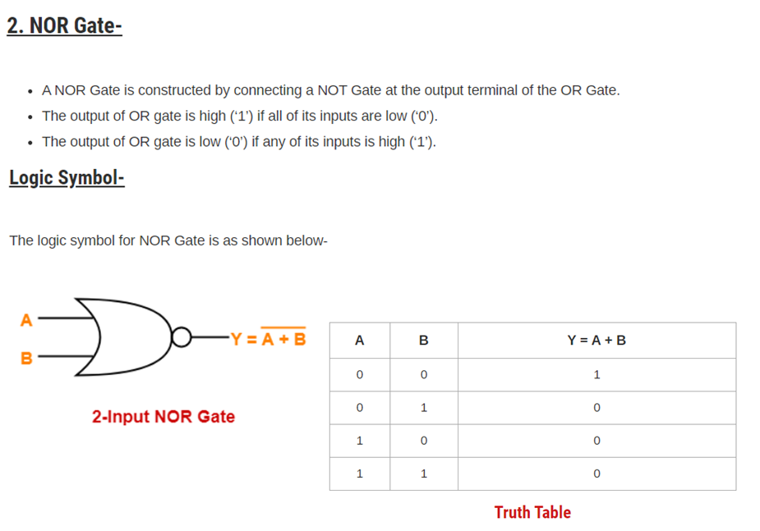
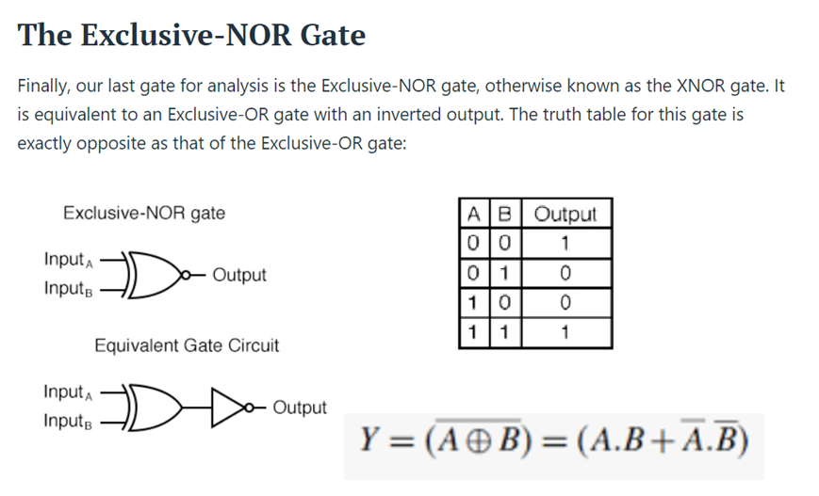

MODULE III
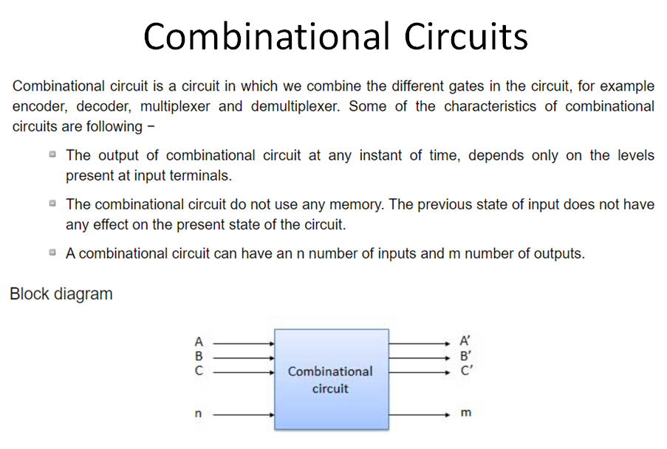
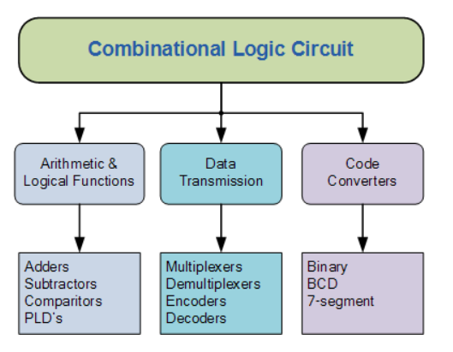
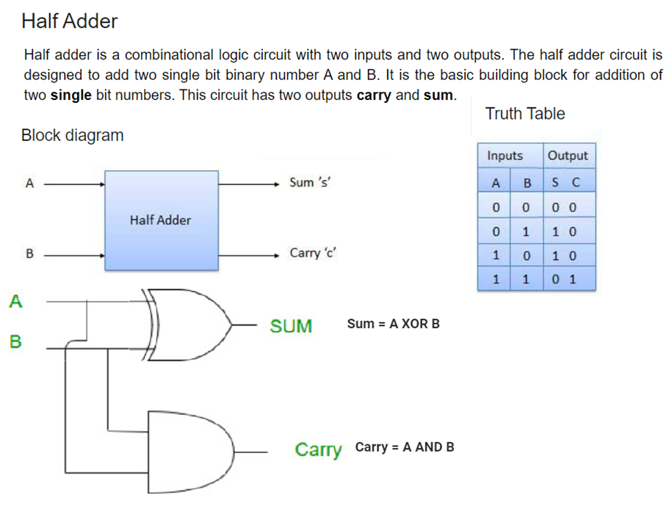
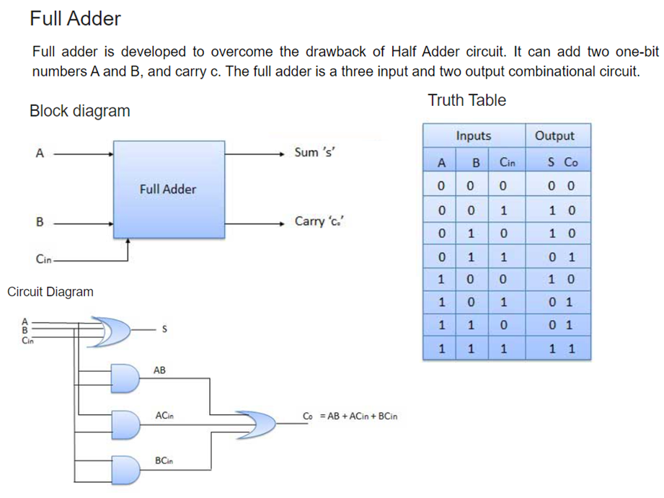
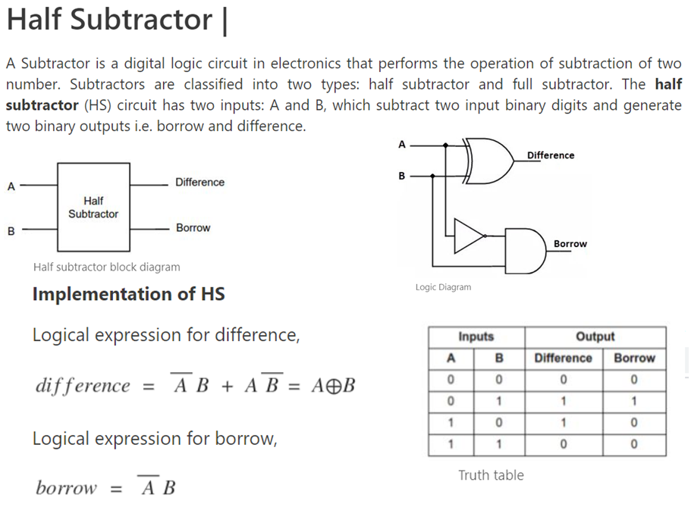
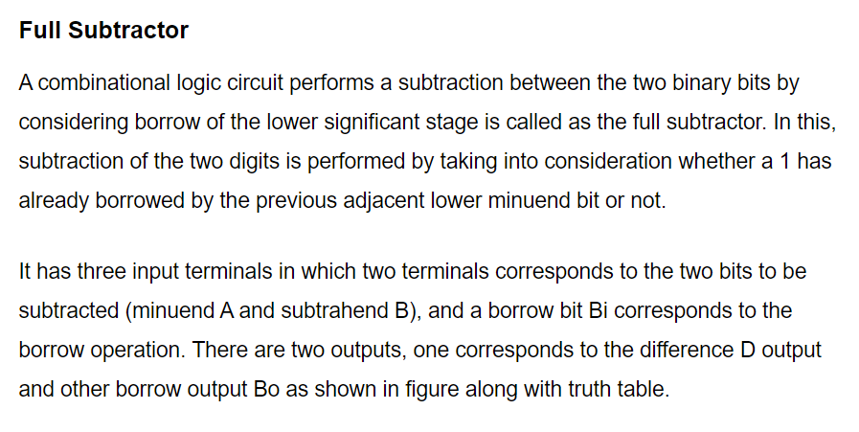
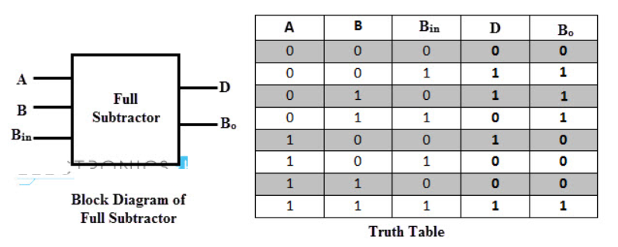
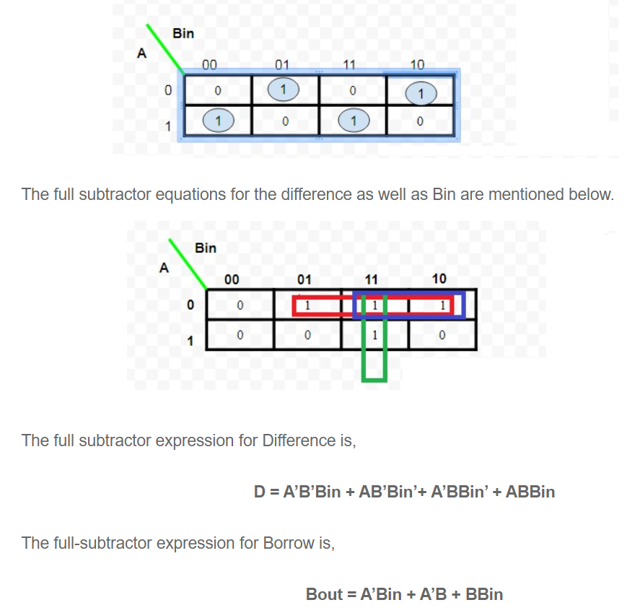
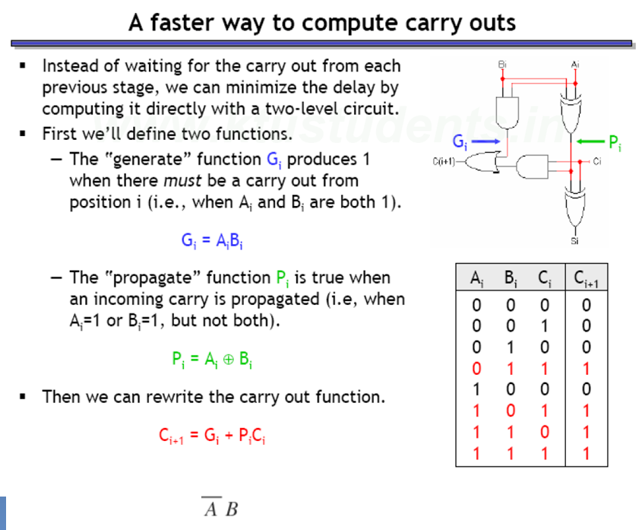
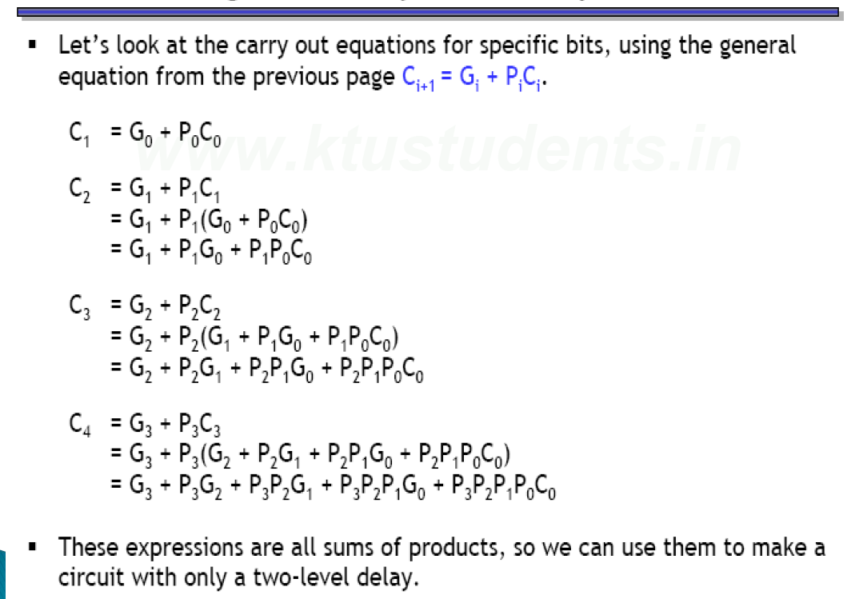
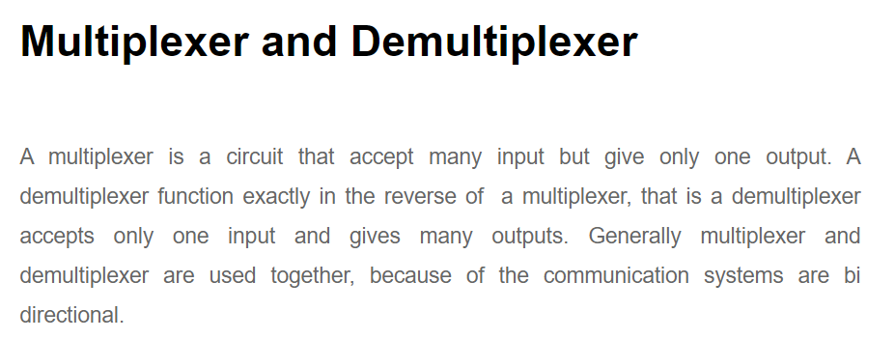
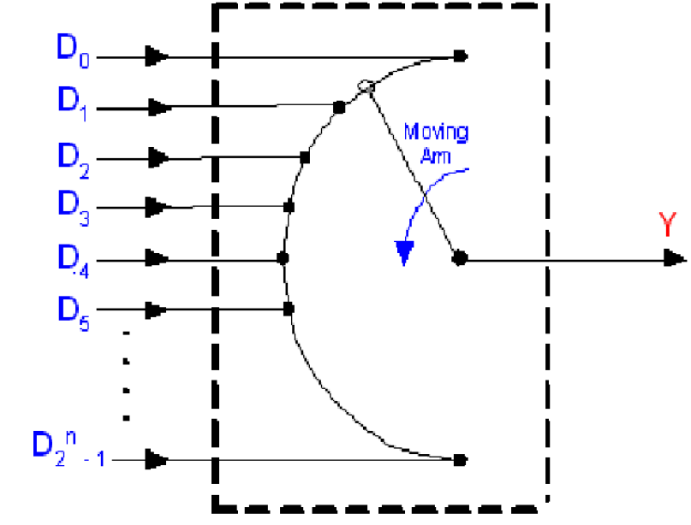
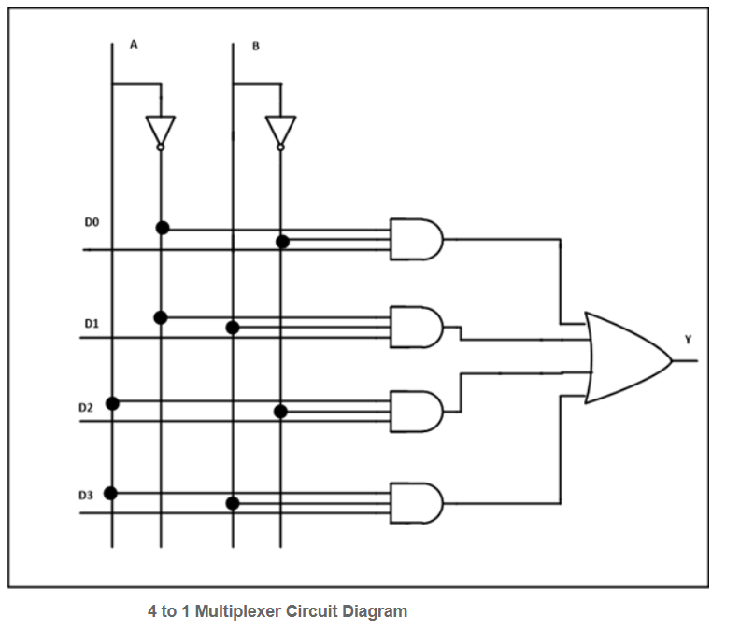
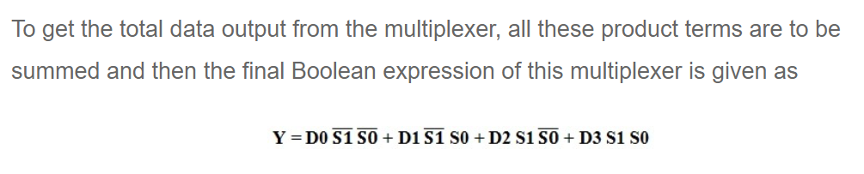
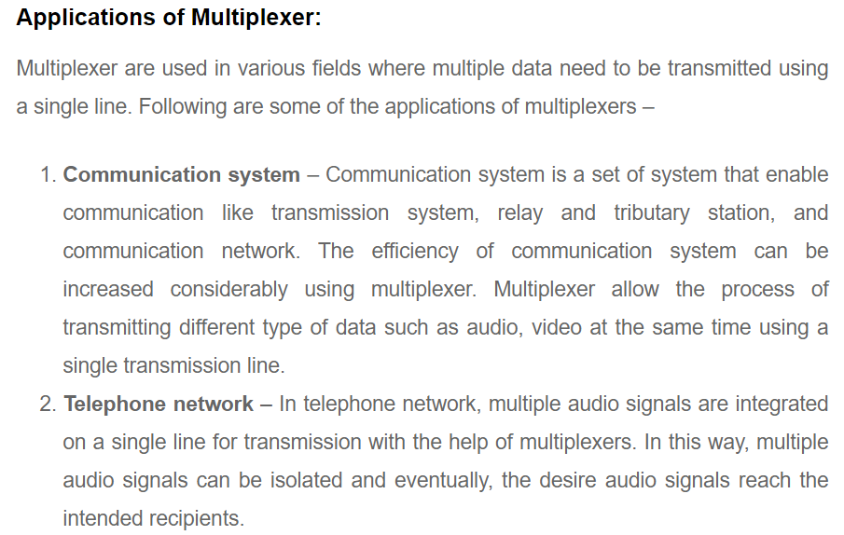
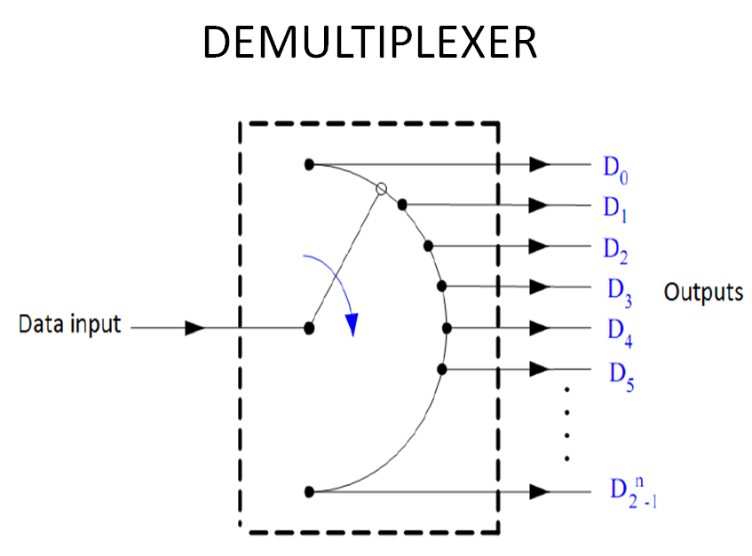
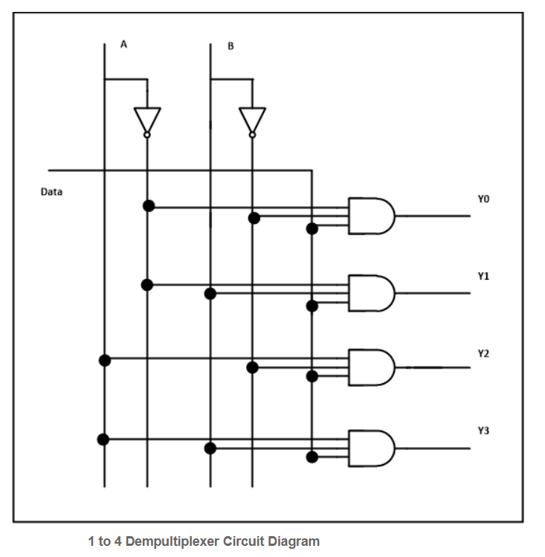
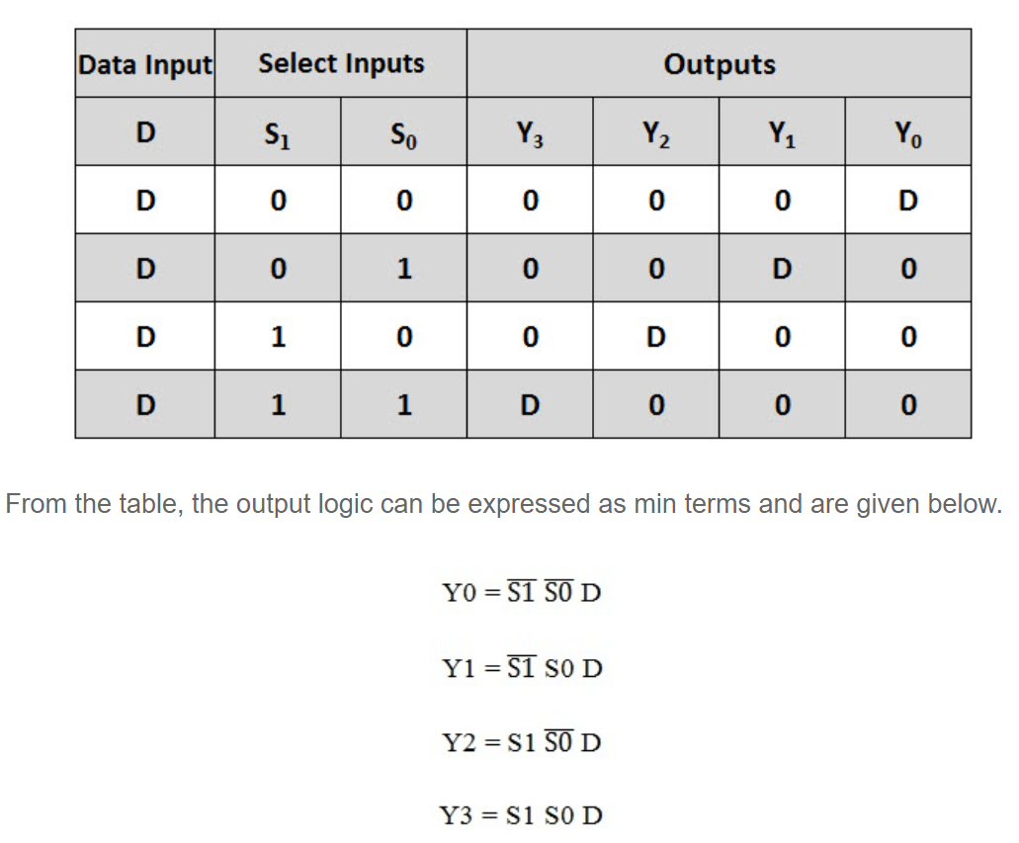
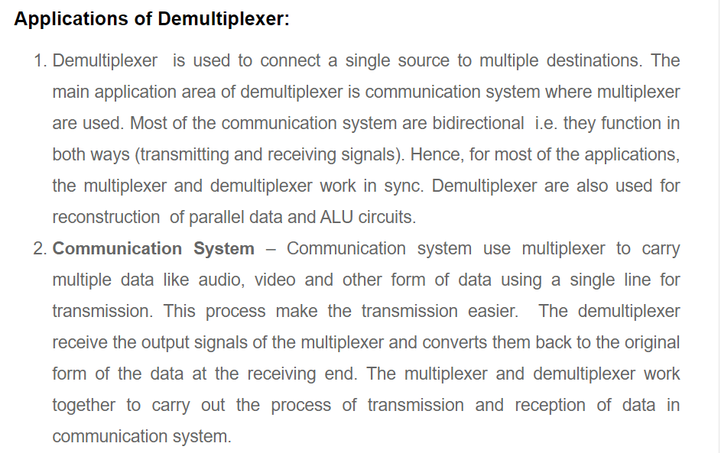
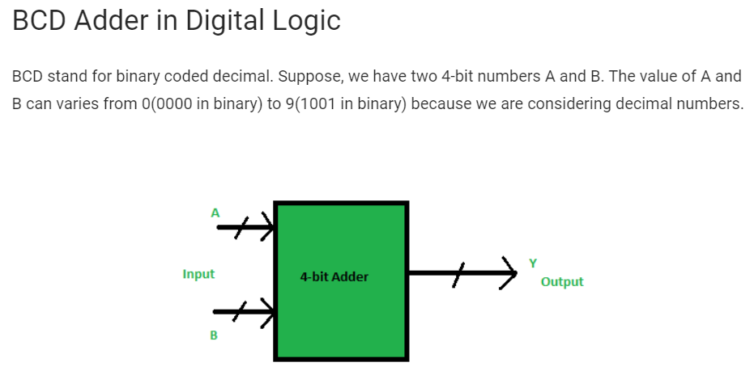
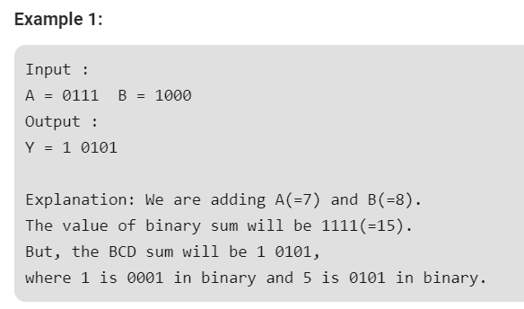
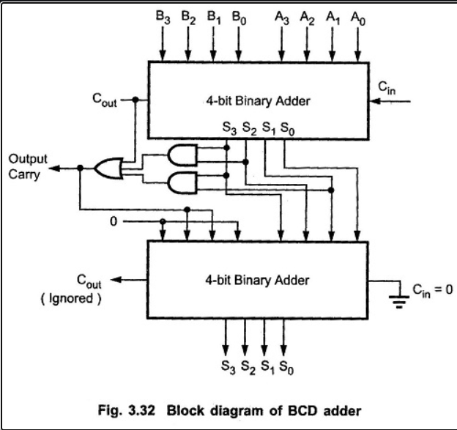
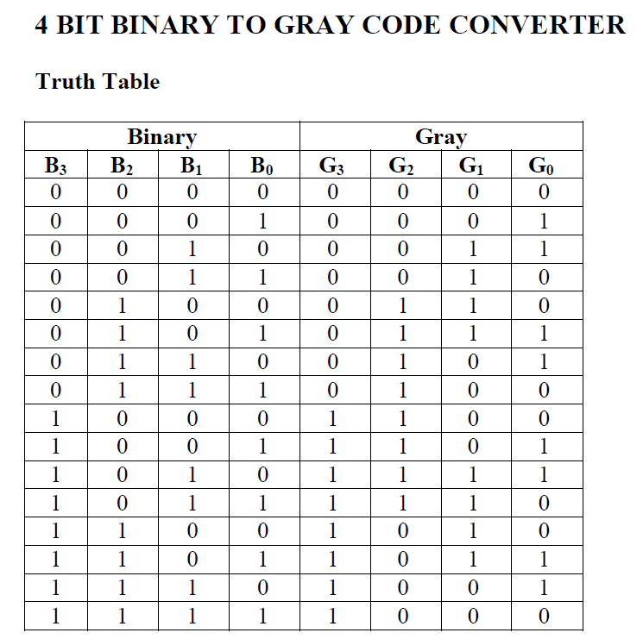
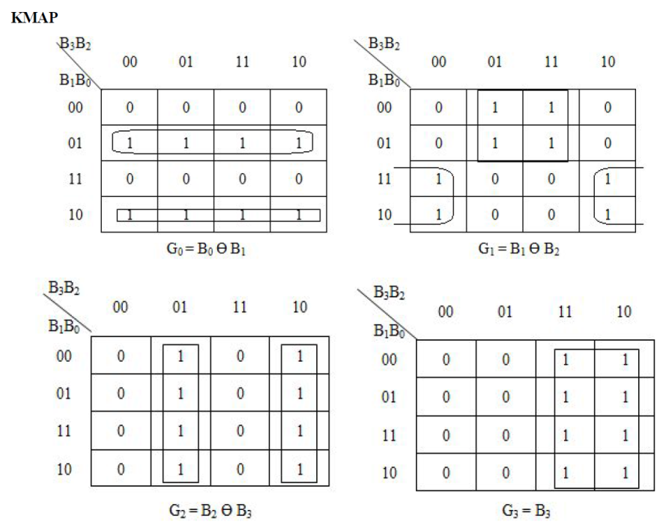
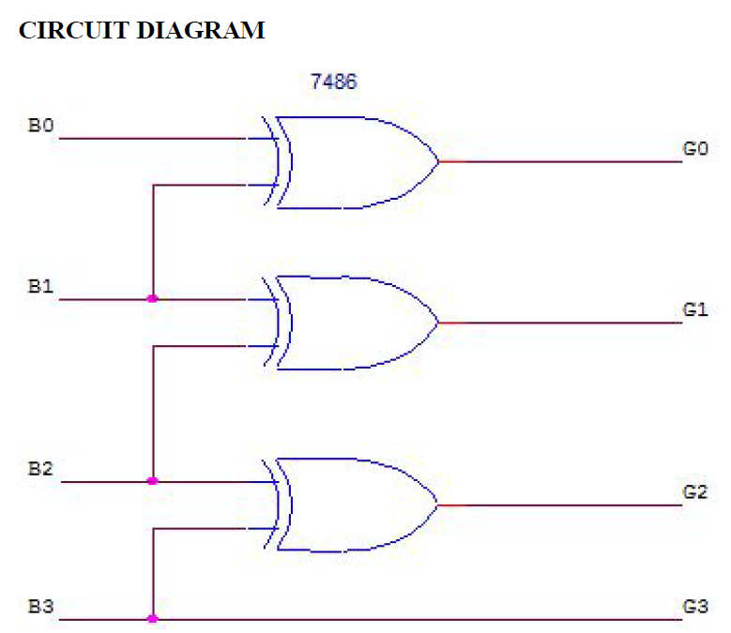
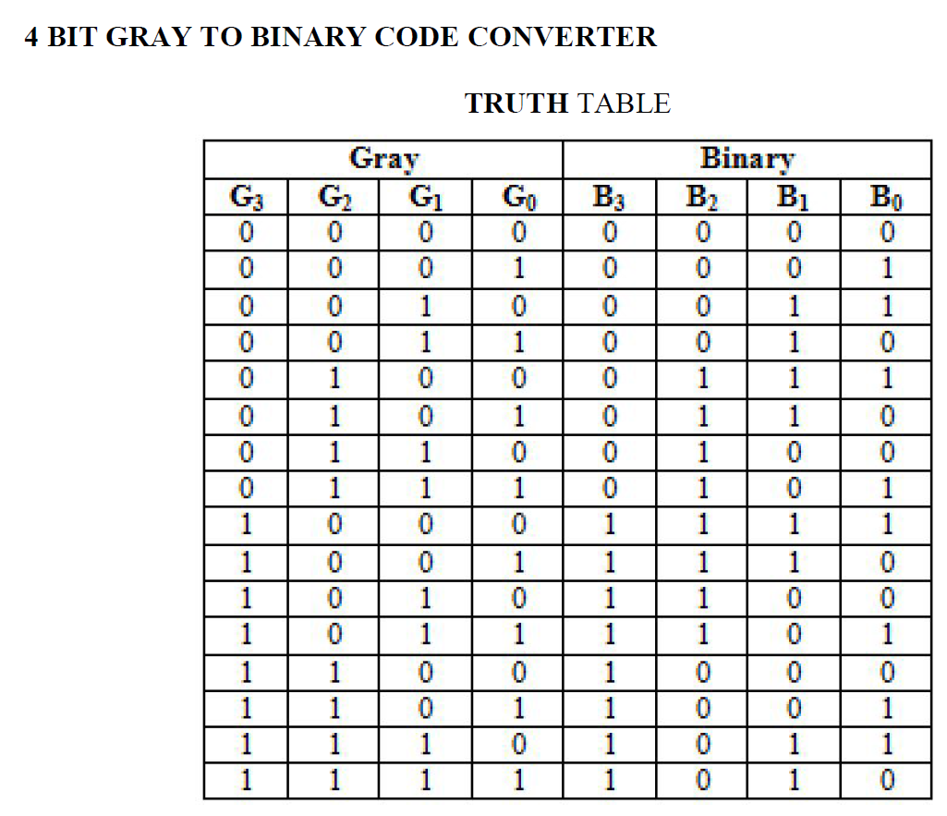
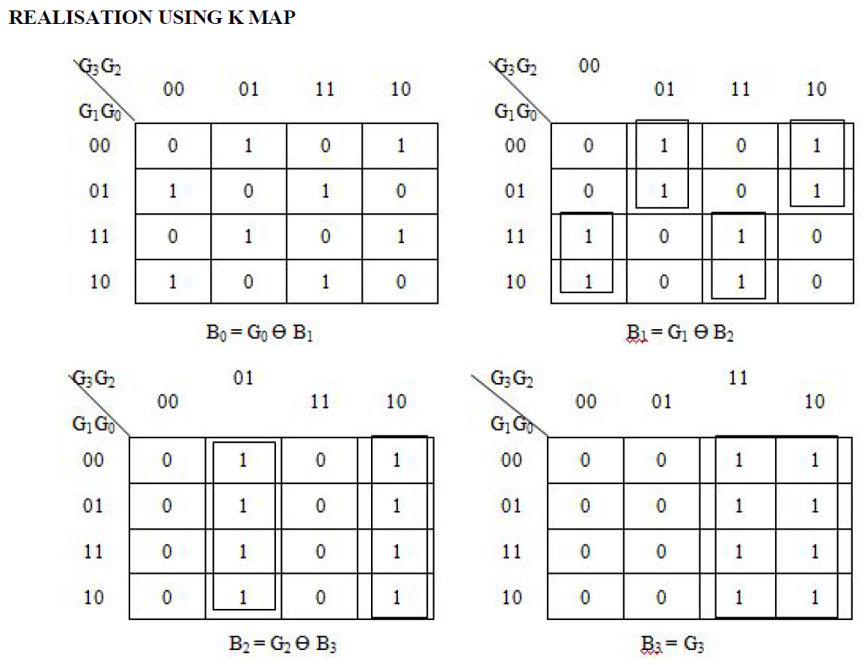
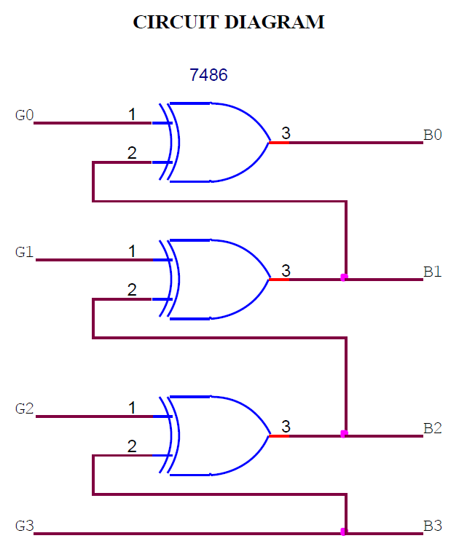
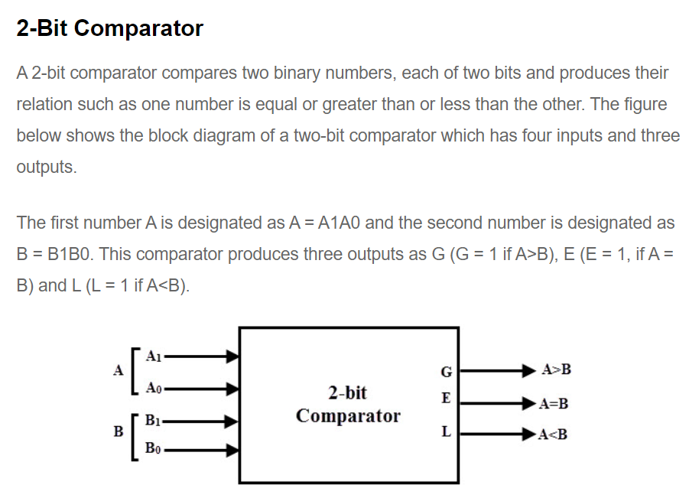
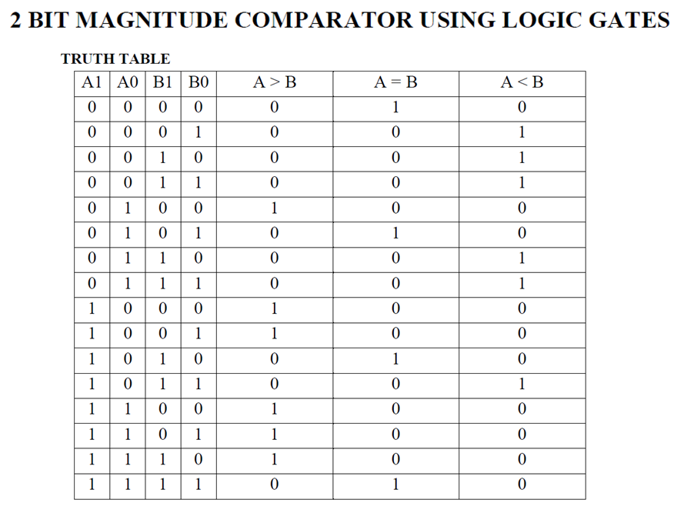
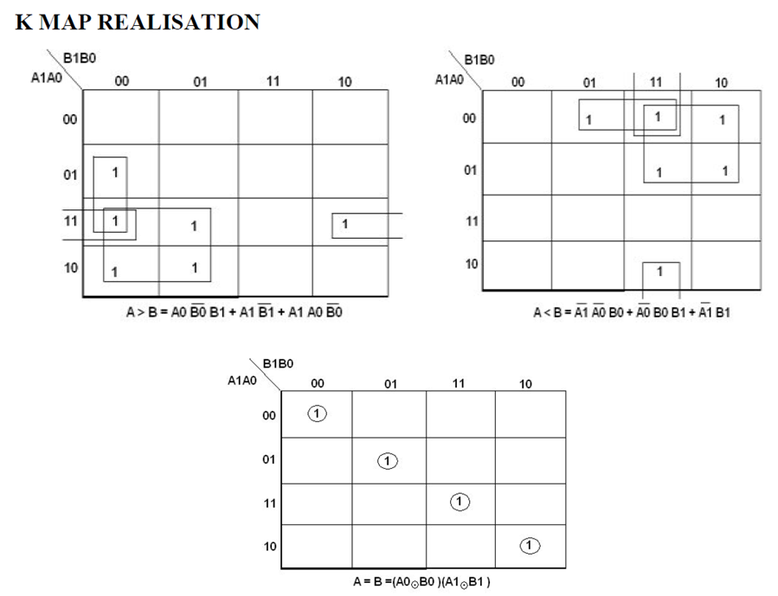
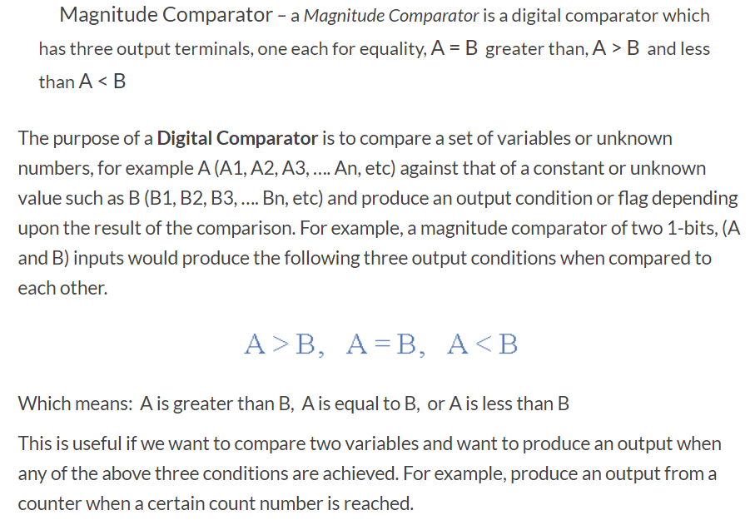
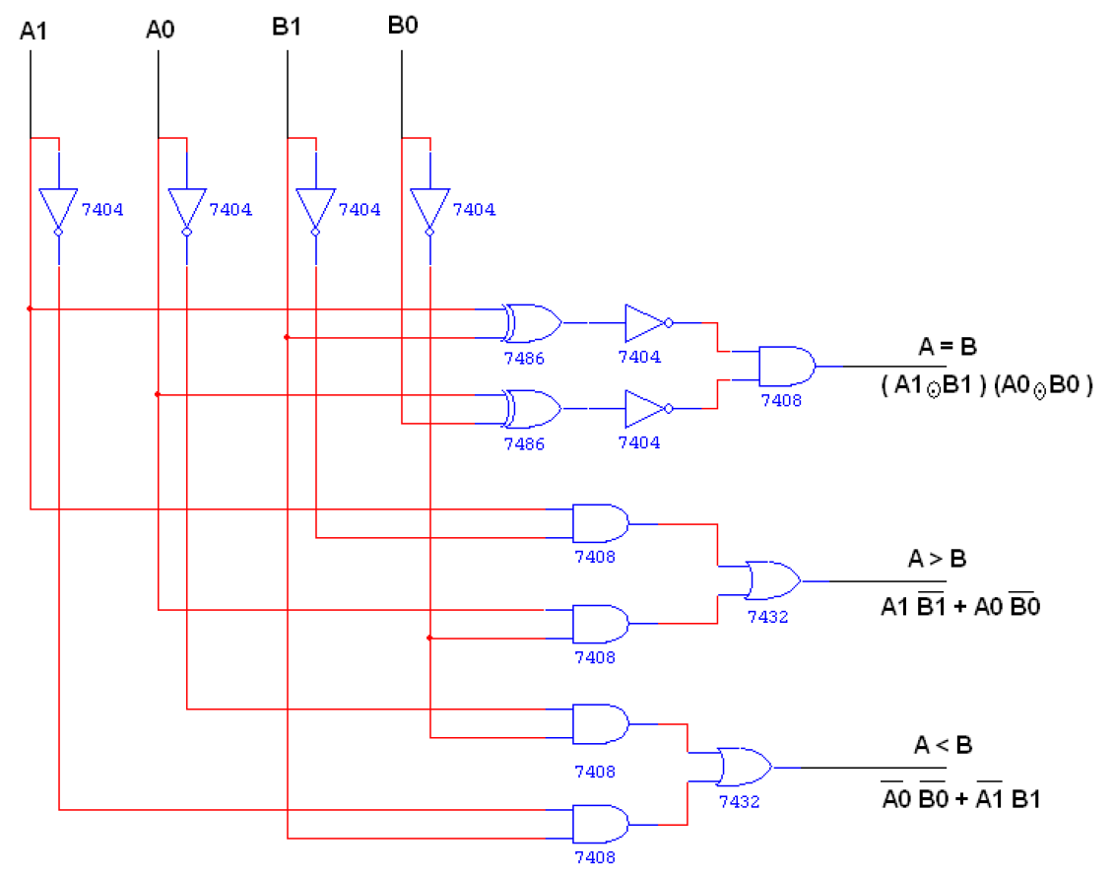

MODULE IV
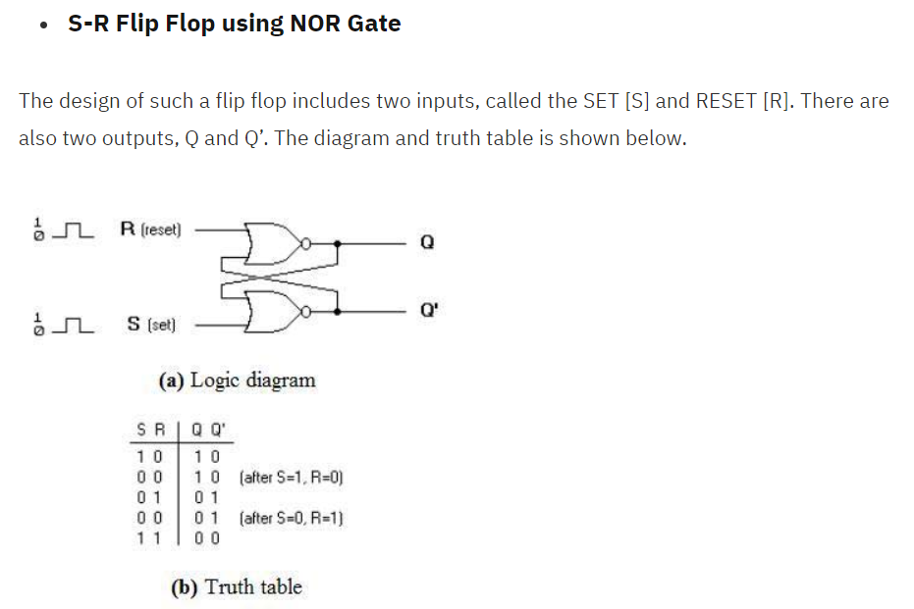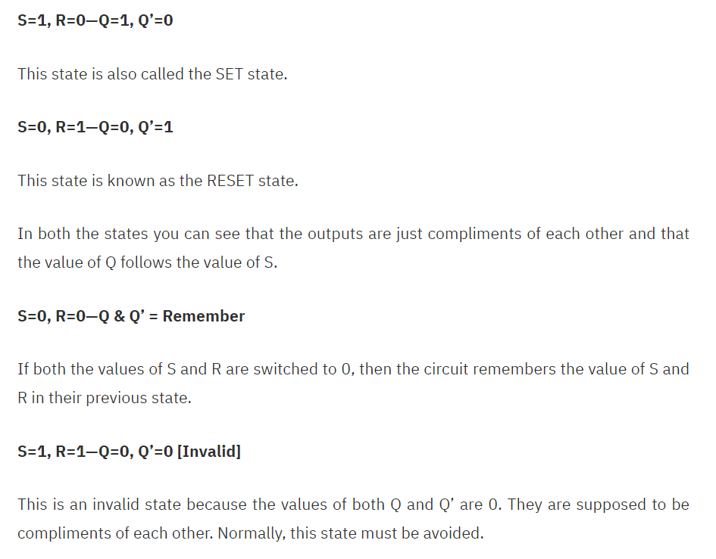
D FLIP FLOP
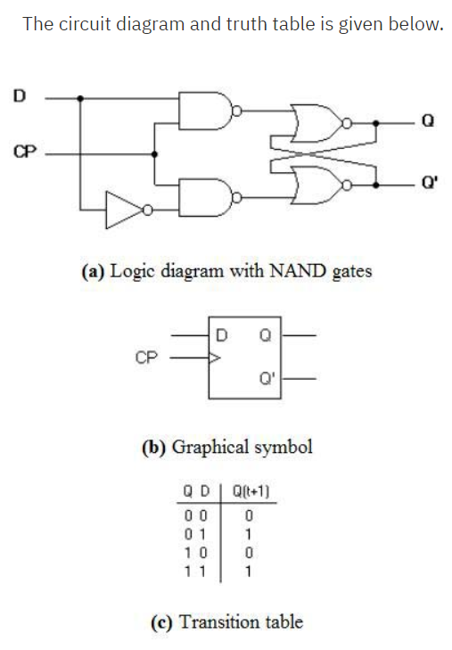
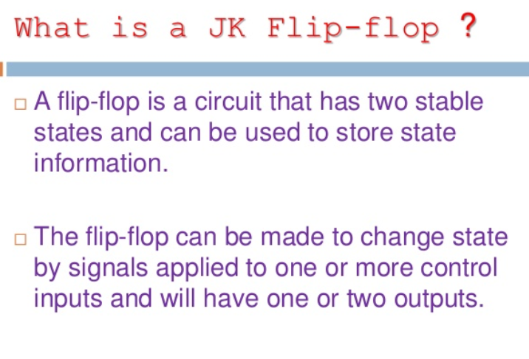
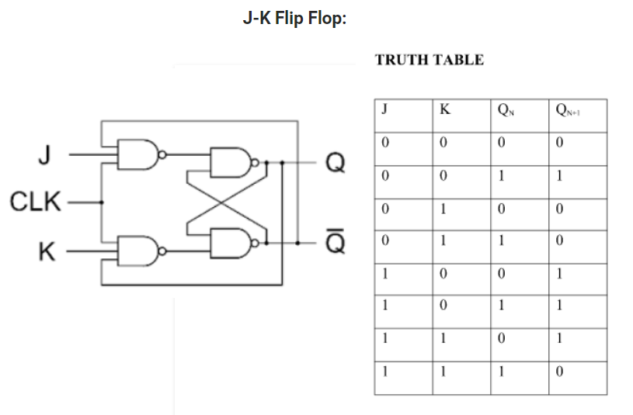
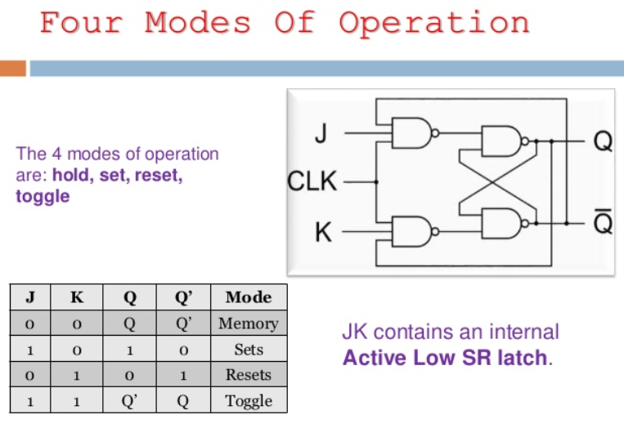

MASTER SLAVE JK FLIP FLOP
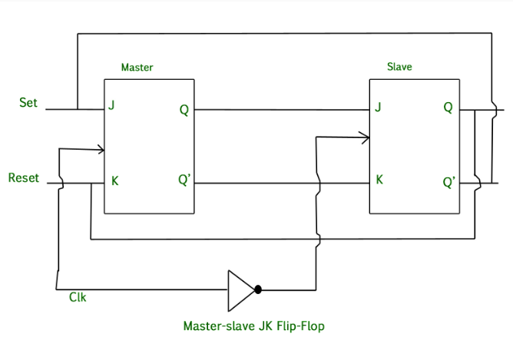
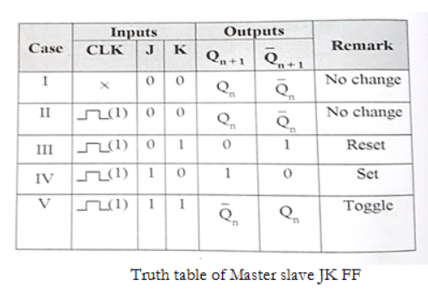
T FLIP FLOP
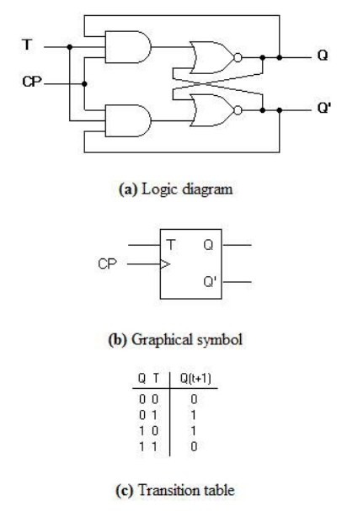
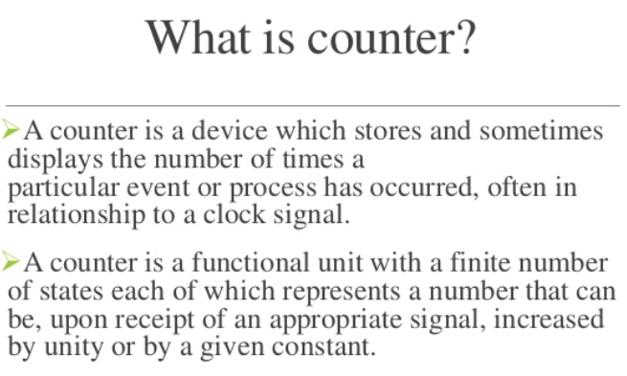
ASYNCHRONOUS COUNTER
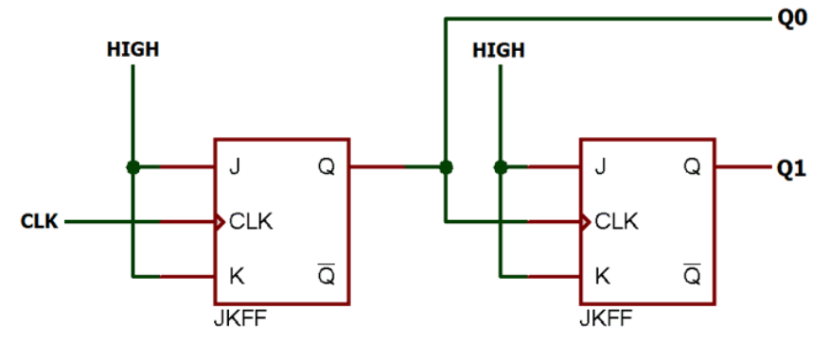
SYNCHRONOUS COUNTER
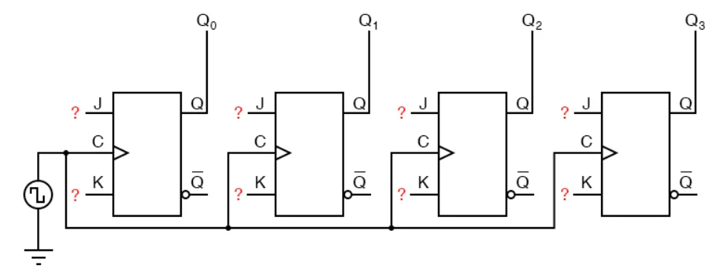
ASYNCHRONOUS UP COUNTER
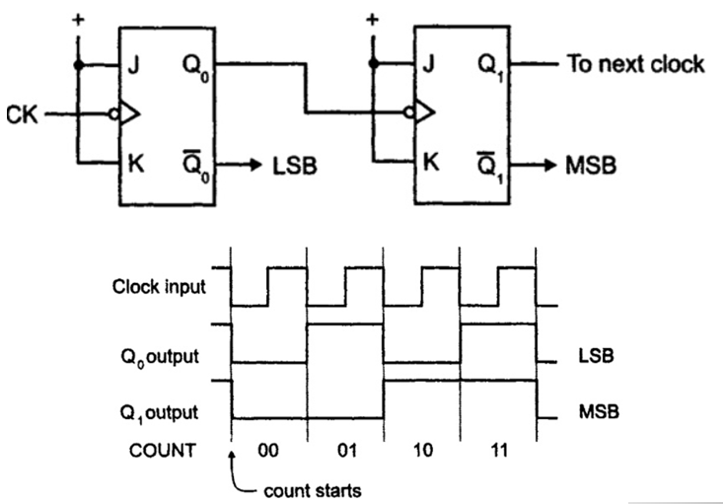
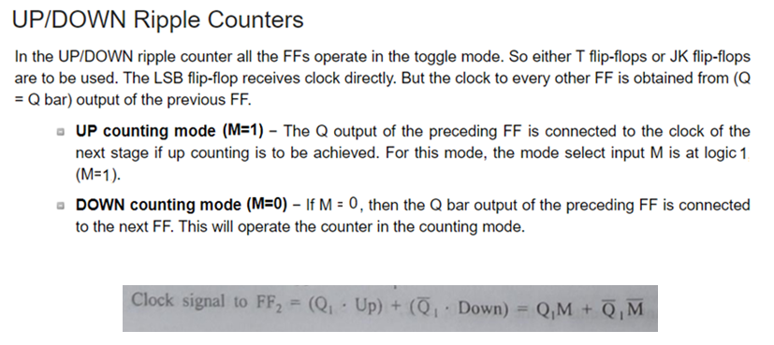
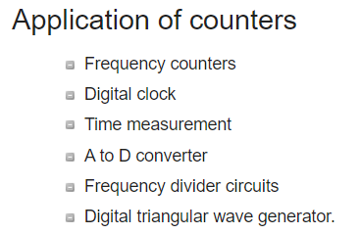
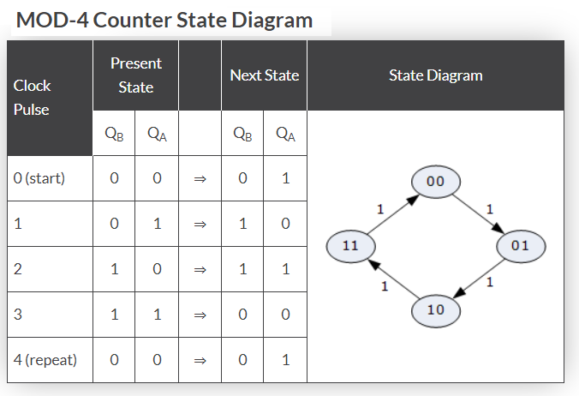

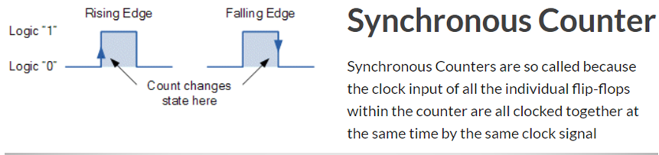
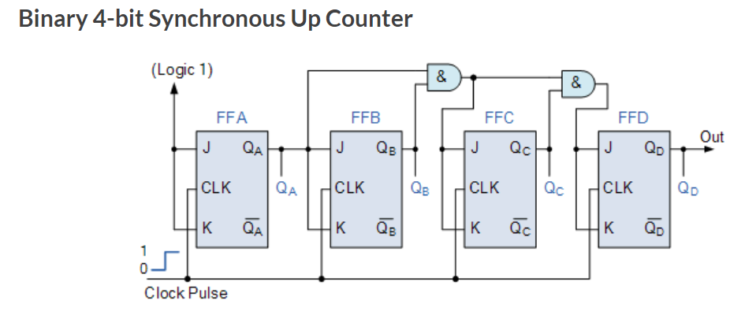
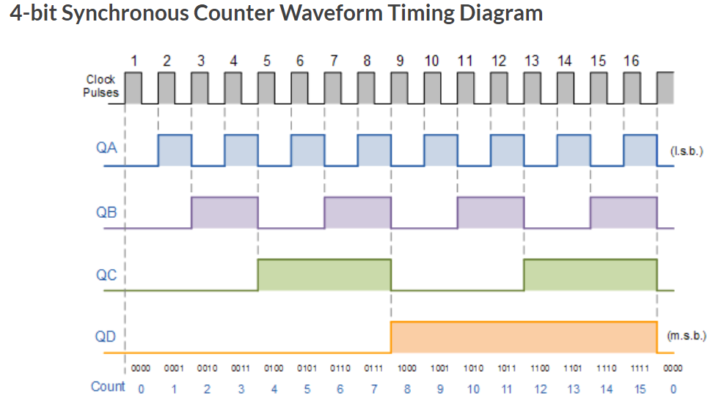
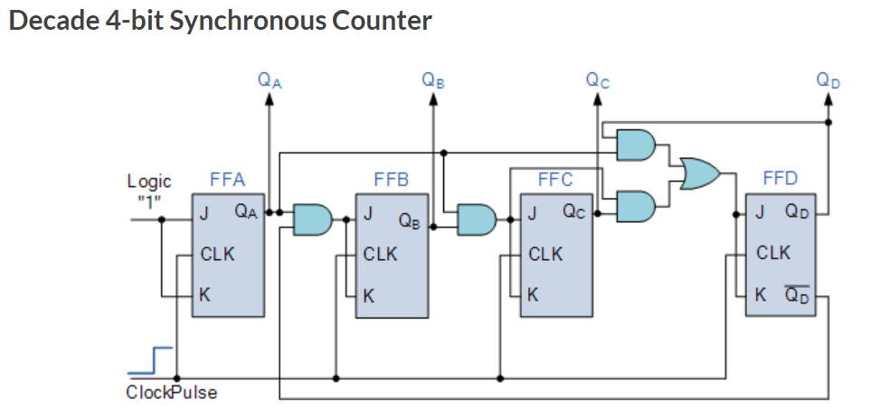
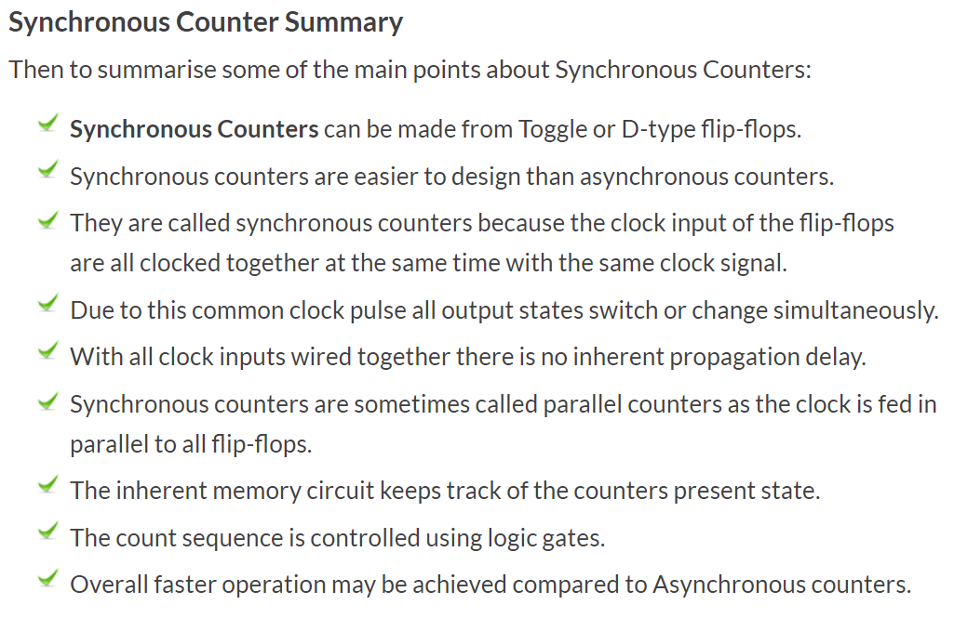

MODULE V
